Governance-Aware Human-in-the-Loop AI for Structuring Longitudinal Autism Intervention Evidence and Generating Evidence-Linked Reports: Development and Component Evaluation Study
Ambar Nath Saha^{1,*}
1 Independent Researcher, Halifax, Nova Scotia, Canada
Debashis Patra²
2 Computer Science, The University of Texas at Austin, Austin, TX, USA
* Correspondence: Ambar Nath Saha | ambar.sah@gmail.com

Abstract
Longitudinal autism intervention review requires specialists to synthesize observations contributed by caregivers, teachers, and intervention staff across settings and time. This study developed a governance-aware human-in-the-loop application intended to reduce evidence-organization burden without transferring intervention authority to AI. The workflow preserves natural-language observations and designates Qwen 2.5 7B for the final frozen research extraction path under the historically evaluated extraction-prompt-v1.0.0 condition, requires professional verification before analytics, checks evidence adequacy deterministically, and produces traceable longitudinal summaries. Component evaluation used ASDBank proxy data segmented into 9,018 behavioral episodes. A model-conditioned main batch contained 330 segments. A separately frozen 132-segment evaluation set was retained transparently after a stable-identity audit; 11 exact episode overlaps were removed without redrawing the sample, yielding a post-audit 121-segment analysis from the originally frozen sampling frame. Two experienced autism-domain specialists independently annotated the evaluation material. Round-1 mean Cohen kappa across four categorical fields was 0.610; a mixed paired pre-audit reliability descriptor across all 330 was 0.801, while the first pass within the frozen evaluation annotation round had mean kappa 0.910 and the overlap-excluded 121-set sensitivity mean was 0.926. The 0.801 value is not a reliability estimate of the later corrected reference. A subsequent model-blind joint final-codebook compliance audit of the 152 unreissued main-batch segments checked 456 targeted labels and corrected 98 labels across 85 segments; preserved model outputs were then rescored against the post-compliance-audit reference. Qwen 2.5 7B achieved 41.3% merged categorical agreement on the main batch and 40.5% on the post-audit overlap-excluded set. The frozen research extractor intentionally retains the historically evaluated prompt condition and therefore does not encode the three later human-codebook clarifications; any final-codebook-aware prompt would constitute a new extraction condition requiring separate evaluation, and mandatory professional verification remains necessary. The offline MARS selector policy returned a record for 80.3% of segments; among the 142 segments with a genuine usable reranking decision, unadjusted exploratory field-level comparisons showed no clear advantage over an in-sample strongest-generator comparator. Under the tested limited-evidence prompt/schema/context/validator contract, none of 11 generative reports passed the full deterministic governance validation, motivating deterministic operational reporting. The findings support a bounded architecture for language-model-assisted evidence organization with professional verification, abstention, provenance, and deterministic downstream controls.
Keywords: autism; large language models; natural language processing; human-in-the-loop AI; trustworthy AI; information extraction; abstention; evidence provenance; longitudinal monitoring; digital health

1. Introduction

1.1. The real workflow problem: one child, many observers, one person who must make sense of it
Longitudinal autism intervention is rarely understood from a single session or a single observer. A parent may notice that a child independently requests help during a morning routine. A teacher may see the same child need repeated verbal prompting in class. A caregiver may describe a behavior that appears only during transitions, while an intervention professional may observe a different pattern under structured conditions. Each observation is incomplete on its own, yet together they can form the evidence needed to understand whether an intervention goal is being practiced, generalized, or obscured by missing context. Prior autism research has shown that parent and teacher reports can diverge across settings and that multi-informant evidence matters for interpretation and planning [1-3]. Digital phenotyping and repeated-measure approaches similarly point toward longitudinal, multi-context observation while cautioning that technology should complement rather than replace professional interpretation [4].
The practical burden falls on the intervention specialist. Before deciding what a pattern means, the specialist must first find the observations, read them, remember which goals they relate to, distinguish a new event from a repeated description, identify what was expected but never submitted, reconcile differences in terminology, and decide whether the available evidence is representative enough to compare settings or time periods. The work is cognitively expensive precisely because the source material is human. Contributors naturally write in different styles, at different levels of detail, and with different knowledge of intervention terminology. A rigid form can standardize data but may erase the contextual details that made the observation useful; free text preserves those details but transfers the structuring burden downstream.
Large language models (LLMs) make that downstream problem tempting to automate. They can transform conversational text into structured fields, summarize multiple observations, and generate readable reports. Similar capabilities are being explored in clinical information extraction, history taking, documentation, and professional workflow support [5-10]. Yet the same generative flexibility that makes LLMs useful creates a specific danger in longitudinal evidence systems: a plausible but unsupported value can become a database field. Once stored, that value no longer looks like a speculative sentence. It can be counted, trended, compared, and repeated in later reports.

1.2. Why a trustworthy system needs more than a better prompt
A governed longitudinal workflow therefore needs to answer several questions that ordinary model-accuracy tables do not. What should happen when the source does not support a prompt level or outcome? How stable are the human definitions used as the reference standard? What prevents a syntactically valid but semantically wrong extraction from entering analytics? When there are too few observations, or all observations come from the same setting or contributor, should the system calculate a cross-setting or cross-contributor result at all? And if an upstream analysis is deliberately withheld, will a downstream language model preserve that absence rather than quietly write around it?
Abstention is central to those questions. Selective-prediction work has shown that withholding a prediction can be preferable when an incorrect answer is more costly than a nonanswer [11], and recent work on LLM abstention in health care emphasizes that generative models are often biased toward answering even when evidence is incomplete [12]. In a longitudinal system, abstention occurs at more than one level. A field can be unsupported within one observation; a set of otherwise valid observations can still be inadequate for a particular longitudinal comparison; and a report must communicate not only what was computed but also what was intentionally not computed.
Trustworthy-AI frameworks increasingly describe traceability, robustness, human involvement, and staged evaluation as lifecycle properties rather than interface decorations [13-16]. For the application studied here, that means an LLM is never the final authority over the longitudinal record. The source observation must remain available, structured interpretations must be reviewable and correctable, analytics must operate only on professionally verified evidence, and the professional must be able to see why a result was withheld.

1.3. Study contribution and objectives
This study develops and evaluates a governance-aware human-in-the-loop application for longitudinal autism intervention evidence. The application is the primary contribution: it is designed around the intervention specialist's workflow, from defining goals and expected observations through collecting distributed free text, structuring that text, verifying the resulting evidence, checking whether the accumulated evidence is adequate, computing descriptive longitudinal indicators, and presenting an evidence-linked professional report. The AI experiments are component evaluations within that workflow. They ask whether the evidence entering the system is defined consistently, whether extraction models leave unsupported fields empty, whether multi-model selection adds value, how extraction agreement changes outside the model-conditioned main batch, and whether a generative reporting layer preserves upstream governance decisions.
The technical novelty is not a new foundation model. It is the integration of evidence-state governance across the full longitudinal pathway. The application keeps unsupported source fields, unverified AI interpretations, inadequate longitudinal evidence, withheld analytics, and withheld report content as distinct states rather than collapsing them into a single notion of confidence. Provenance is preserved from a downstream indicator or report statement back to the structured record and original observation. The component evaluations are therefore used to test different failure boundaries in the same evidence pathway rather than to claim that one model solves the entire workflow.
The study had five objectives: (1) implement the complete controlled-environment workflow while preserving intervention specialist authority; (2) develop and assess a documented human reference-standard process for structured observation fields; (3) evaluate locally served instruction-tuned LLMs for exact-match agreement, null/missing output, and unsupported assertion without model training or fine-tuning; (4) evaluate an offline multi-judge reranking strategy and a separately frozen evaluation sample, including a post-audit overlap-excluded analysis and sensitivity analysis of the model-conditioned design; and (5) test whether downstream reporting preserves explicit withholding states, numeric traceability to supplied packet values, and valid evidence-reference identifiers. The study does not evaluate diagnosis, treatment efficacy, intervention effectiveness, child outcomes, or production deployment.

2. Materials and Methods

2.1. Study design
This was a staged development and component-evaluation study. The development arm produced a functioning role-based application for controlled research use. The empirical arm evaluated the reference-standard process, four locally served extraction models, an offline multi-judge reranking experiment, a separately frozen evaluation sample with an overlap-excluded sensitivity analysis, and a separate generative reporting experiment. The evaluation data are proxy data for the extraction component rather than real observations submitted through the application; this boundary is stated explicitly because the source distribution differs from the intended application input.
The design follows a simple principle: generative AI is used only where language understanding or language generation is useful, while access control, schema enforcement, evidence-state transitions, adequacy decisions, numerical analytics, versioning, and operational reporting are deterministic. Human professional verification sits between AI extraction and longitudinal analysis.

2.2. Intended use and explicit nonuse
In this study, intervention specialist is a functional term for the qualified professional who defines or reviews individualized goals, determines observation expectations, interprets longitudinal evidence, and retains professional authority for intervention decisions within the person's scope of practice. The exact professional title can differ across behavioral, speech-language, educational, developmental, and related autism-support settings. The application therefore models professional authority through permissions and workflow responsibility rather than assuming that one job title applies in every setting.
The intended use is evidence preparation for longitudinal autism intervention review. An intervention specialist defines the child workspace, active goals, review period, authorized contributors, relevant settings, and observation expectations. Contributors describe what they observed in ordinary language. The application organizes those observations into versioned structured evidence, identifies missing or underrepresented evidence, computes descriptive indicators only when prerequisites are met, and presents the result for professional review.
The system is not designed to diagnose autism, determine eligibility for services, prescribe or recommend treatment, autonomously create or modify intervention goals, replace standardized assessment instruments, rank children, infer causal explanations for behavior, or make a final judgment that a child has clinically improved. A contributor's permission to submit observations does not confer professional decision authority. The intervention specialist remains responsible for interpreting the evidence and deciding whether an intervention goal or strategy should continue, change, pause, or end.

2.3. End-to-end application workflow
The application workflow begins with the intervention specialist rather than the AI. For each child, the specialist creates a protected workspace, defines the active long- and short-term goals and observable indicators, establishes the review period, identifies the settings in which evidence is expected, authorizes the people who may contribute observations, and configures when those observations are expected. The purpose of the application is to reduce the repeated organizational work required to reconstruct this context from scattered notes while leaving the meaning of the evidence and all intervention decisions with the professional.
Evidence is then collected from the people who actually observe the child across daily contexts. A parent or caregiver may contribute from home, a teacher or educational support person from school, and an intervention professional or trainer from a structured session. Each contributor is restricted to the child, goals, and functions for which access has been granted. Observation expectations are linked to the relevant child, goal or goal set, contributor role, setting, and cadence. When an expected observation is late or absent, the system records a missing-evidence event; it does not interpret the absence as lack of progress.
When an authorized contributor submits an observation, the contributor writes in ordinary language rather than completing a long structured form. The application supplies administrative context that it already knows, including child identifier, contributor role, date, session, setting, and linked goal. The original narrative remains immutable. Qwen 2.5 7B is designated for the final frozen research build for the narrower task of proposing structured fields supported by the observation, using the historically evaluated extraction prompt version 1.0.0. That prompt does not encode the three later specialist codebook clarifications; this condition is retained to match the evaluated extraction condition, while every proposed record remains subject to mandatory professional verification. If an important detail is unclear but potentially recoverable from the observer, the application may ask a focused clarification question. Unsupported information remains null or unknown rather than being invented to complete the record.
The proposed structured record is not treated as longitudinal evidence merely because it is syntactically valid. An authorized intervention specialist must compare the proposal with the source observation and either verify it, correct it, or reject it. Only VERIFIED or CORRECTED records are eligible for longitudinal analytics. Corrections create a new structured version while preserving the original note and prior versions. As verified evidence accumulates, a deterministic router checks whether there is enough evidence, whether it is distributed adequately across time, contributors, settings, and active goals, and whether field completeness is sufficient for the requested analysis. When prerequisites are not met, the relevant analysis is explicitly withheld rather than approximated.
For analyses that are supported, deterministic code calculates descriptive longitudinal indicators. The intervention specialist dashboard brings together the goals and review period, expected versus received observations, overdue or unresolved evidence, representation and adequacy warnings, verified records, eligible KPIs and trends, and explicit abstention states. The operational report is deterministic and preserves the same evidence and withholding decisions. The intervention specialist can drill from a report or indicator back to the structured record and then to the original observation. The professional then decides what the accumulated evidence means and whether the intervention plan or monitoring goals should continue, change, pause, or end. Any future change applies prospectively to the next monitoring cycle; the AI does not make or enact that decision.
In practical terms, the integrated workflow follows the sequence below:
- The intervention specialist creates the child workspace, records only the background needed for monitoring, defines goals and observable indicators, and establishes the review period.
- The intervention specialist authorizes contributors and assigns child-, goal-, setting-, and role-specific access.
- Observation expectations are configured by goal and contributor; overdue expectations are surfaced as missing evidence and may trigger reminders.
- An authorized contributor enters a natural-language observation inside the assigned child and goal context.
- The designated final-build extractor, Qwen 2.5 7B, proposes a structured record through the extraction tool schema and may request a focused clarification when a material detail is recoverable.
- Deterministic validation checks schema, allowed values, provenance, and explicit null/unknown states; unsupported information is not forced into a value.
- The intervention specialist verifies the proposed record, corrects it, or rejects it. Unverified AI-derived records cannot enter longitudinal analytics.
- Verified and corrected evidence is retained in a versioned store linked to the immutable source observation, actor, timestamp, model/configuration, and audit events.
- At review time, the adequacy and representation router evaluates coverage, temporal distribution, contributor and setting representation, active-goal coverage, and completeness. Full or partial abstention is used when prerequisites are not met.
- For eligible analyses, deterministic code calculates descriptive longitudinal indicators; the dashboard and operational report present results, warnings, withheld states, and evidence drill-down together.
- The intervention specialist interprets the evidence and independently decides the next professional action. A changed goal, schedule, or monitoring plan begins a new prospective cycle without rewriting historical evidence.
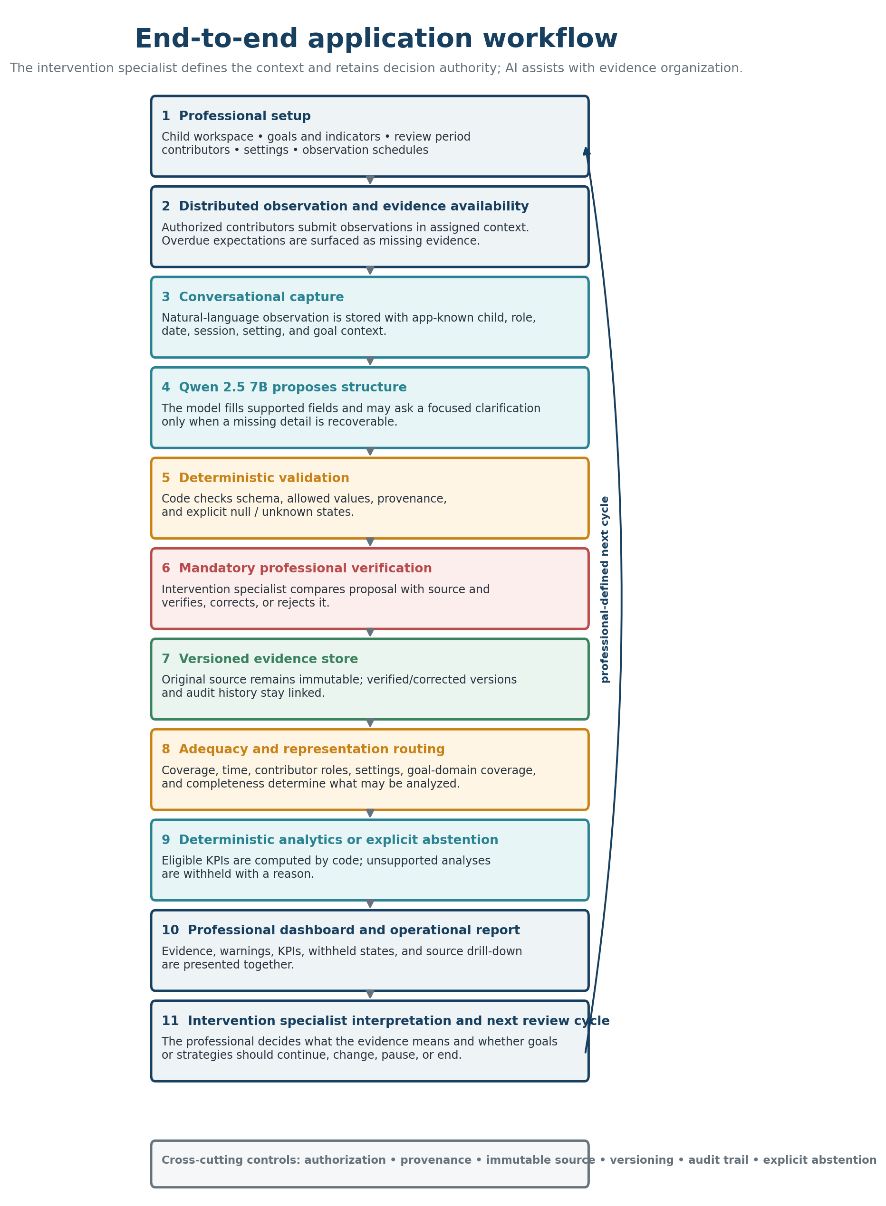
Figure 1. End-to-end application workflow. The intervention specialist defines the monitoring context and retains decision authority. Contributors provide natural-language observations; the designated final-build Qwen 2.5 7B extractor proposes structure; deterministic validation and mandatory professional verification govern what enters the versioned evidence store; adequacy and representation checks determine which analyses may be computed; and the professional dashboard preserves both results and explicit withheld states. Authorization, provenance, versioning, auditability, and abstention span the workflow. The extractor designation is subject to the final configuration-alignment and end-to-end verification described in Section 2.20.
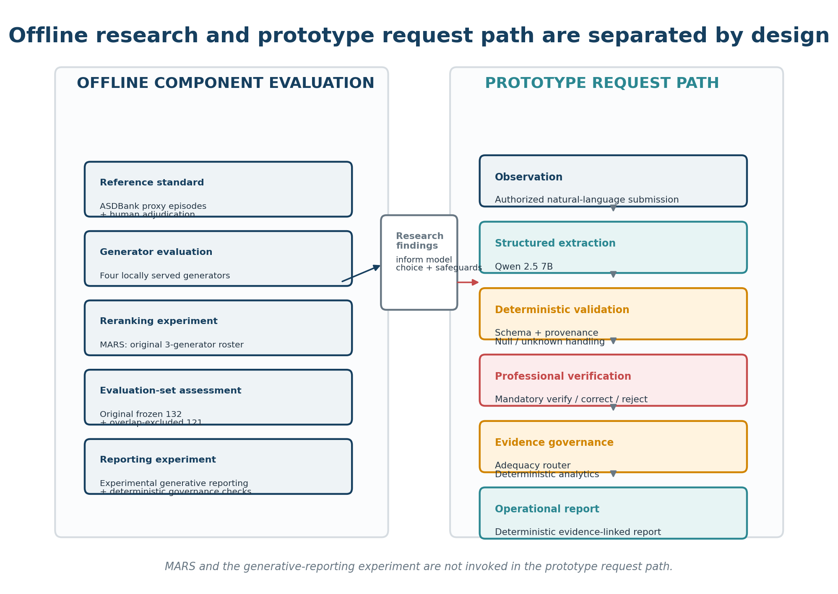
Figure 2. Separation of offline component evaluation from the prototype request path. MARS and generative reporting remain offline/experimental; research findings inform the designated final-build prototype extractor and governance safeguards, with final configuration alignment verified before submission.

2.4. Roles, authorization, and child workspaces
Each child workspace is owned operationally by an intervention specialist. The workspace contains only the background information needed for longitudinal monitoring, the active goals and observable indicators, the review period, the settings in which evidence is expected, the authorized contributors, and their observation responsibilities. Creating the workspace does not give the AI authority to infer a diagnosis, create a goal, or determine an intervention plan. Goals and observation expectations originate from the professional and become controlled context for later capture, review, and analysis.
Table 1. Role-based permissions in the child-specific longitudinal intervention workspace.
Application function | Intervention specialist/owner | Contributor | Secondary professional
Create/manage child workspace | Allowed | Not allowed | Only if explicitly authorized
Define/edit goals and review context | Allowed | Not allowed | Within professional permission
Invite/revoke contributors | Allowed | Not allowed | Not allowed by default
Configure setting/cadence responsibilities | Allowed | Not allowed | Not allowed by default
Submit observations | Allowed | Assigned child/goals only | If assigned
Answer clarification questions | Allowed | Own submission only | Own submission unless authorized otherwise
Verify/correct structured evidence | Allowed | Not allowed | Professional permission only
View adequacy warnings, analytics, report | Allowed | Not allowed | Professional permission only
Make intervention decisions | Human professional authority | No | According to professional authority

The intervention specialist invites contributors using the minimum information required for account provisioning and assignment, such as name, email address, role, child assignment, and observation responsibility. Candidate contributor roles include parent or caregiver, teacher or educational support staff, trainer or home implementor, secondary professional, and another explicitly authorized contributor. Access is child-specific and role-specific: an invited contributor cannot browse unrelated children, create or alter professional goals, change another user's permissions, verify structured evidence, or view professional analytics unless a separate professional permission explicitly allows it. Invitations, activations, role changes, permission changes, and revocations are versioned events. Revocation prevents future access while preserving prior submissions and audit history. Permission enforcement is intended at both the user-interface and service/API layers so that hiding a control is never treated as authorization.

2.5. Goal-linked scheduling and missing-evidence management
Observation expectations are attached to a child, goal or goal set, contributor role, setting, and cadence rather than to the child globally. A child may have several active goals at the same time, and different people may be responsible for observing different goals in different settings. Calendar-based schedules can represent recurring expectations, while event-based schedules can represent an observation expected after a specific intervention session. The schedule therefore supplies the denominator for evidence availability and lets the system distinguish a missing expected observation from a submitted observation that contains missing fields.
When an expected submission becomes overdue, the application records an evidence-availability event and can notify the responsible contributor and intervention specialist. The overdue state is also visible to the professional during review. A reminder communicates only that expected evidence has not been received; it does not infer that the child failed to progress and it does not create a substitute observation. Changes to cadence, responsible actor, required setting, or review period apply prospectively and are versioned so that later configuration changes do not silently rewrite what was expected during an earlier period.

2.6. Conversational observation capture and clarification
Authorized contributors enter observations through a conversational interface rather than a long fixed form. The interface is opened inside the assigned child and goal context, and the application supplies app-known metadata such as child identifier, contributor role, observation date, session identifier, setting, and schedule context rather than asking the LLM to invent them. The contributor describes what was observed in ordinary language, and that original narrative is retained immutably as source evidence linked to every derived structured version.
When a material detail is ambiguous and potentially recoverable from the person who observed the event, the system may ask a narrowly scoped clarification question. For example, a contributor may report that the child completed an activity after being reminded while leaving the type of prompt unclear. The system can ask about that observed detail without asking the contributor to diagnose the child or speculate about causes. The contributor may answer, indicate that the detail is unknown, or stop the clarification; the record can preserve unknown or unsupported values rather than forcing completeness.
The conversational interface is therefore an evidence-capture mechanism, not an autonomous counseling or intervention agent. It cannot create or modify goals, recommend treatment, interpret a behavior causally, or replace the professional review that follows extraction.

2.7. Mandatory professional verification, versioning, and analytics eligibility
A central governance change in the final architecture is that schema validation is not treated as semantic validation. The extraction pipeline can establish that a value belongs to the permitted vocabulary; it cannot establish that the value is a correct interpretation of the source. The operational evidence state therefore includes a mandatory professional gate. AI-derived records that are schema-valid remain in a pre-analytic state until an authorized intervention specialist either verifies the record as written or corrects it. Records routed as pending because evidence was inadequate cannot be verified unchanged; they must be corrected or rejected.
Verification changes review state rather than evidence content and therefore does not create a new content version. The verifier and timestamp are stored and audited. Corrections create a new version while preserving the immutable source observation and prior structured version. Existing records that had previously been marked only as validated were not retroactively promoted to verified. The analytics query admits exactly records with VERIFIED or CORRECTED status. This gate is enforced in code and covered by backend tests; it is not merely a user-interface warning.
When a structured record is corrected, downstream adequacy decisions, deterministic analytics, and operational reporting are regenerated from the corrected evidence so that the same extraction error does not continue to propagate through later review periods. Human corrections may be curated as labeled examples for future offline research, but they do not automatically update the active model or trigger uncontrolled online learning.
The purpose of the gate is not to claim that professionals will catch every error. That question—particularly the risk of automation bias—remains unevaluated. The gate instead prevents an unreviewed LLM interpretation from becoming longitudinal analytic input by design.

2.8. Evidence adequacy, representation, analytics-level abstention, and deterministic analytics
After verified observations accumulate, a deterministic adequacy router evaluates whether the review period contains enough and sufficiently distributed evidence for longitudinal analysis. Six checks are applied to all VERIFIED or CORRECTED records for the child in that review period: observation coverage, temporal distribution, contributor-role representation, setting representation, goal-domain coverage, and field completeness. These are implementation-defined prototype governance thresholds, not clinically validated cutoffs.
Representation is not currently evaluated per goal. The prototype requires at least two distinct contributor roles and at least two settings across the child's accepted records in the review period. The router is not passed a goal identifier and the Goal model does not define a single-setting or single-contributor exemption. A failure of either representation check prevents an ADEQUATE rating and withholds the matching cross-setting or cross-contributor comparison, but by itself does not withhold other supported analytics. Goal coverage is evaluated separately at the domain level. This deliberately conservative prototype behavior is reported as implemented rather than interpreted as a clinically validated rule.
Table 2. Prototype evidence-adequacy and representation rules used by the deterministic router. These values are implementation-defined governance thresholds, not clinically validated cutoffs.
Prototype rule | Current value | Purpose
Observations for an adequate state | 5 | Separates ADEQUATE from lower evidence states when no checks fail
Observations for a limited state | 3 | Separates LIMITED from INSUFFICIENT in low-volume cases
Field completeness | 0.70 | Flags inadequate populated-field coverage
Temporal clustering ratio | 0.80 | Flags evidence concentrated in one time window
Distinct settings | >=2 | Global review-period setting representation; fewer than 2 withholds cross-setting comparison and prevents ADEQUATE
Distinct contributor roles | >=2 | Global review-period contributor-role representation; fewer than 2 withholds cross-contributor comparison and prevents ADEQUATE
Goal coverage | 0.50 | Requires evidence for at least half of active goals

Zero records are insufficient. A critical failure of coverage or field completeness with fewer than three records is insufficient; otherwise a critical failure yields limited evidence. More than two failed checks or fewer than three records also yield limited evidence. At least five records with no failed checks are adequate; remaining cases are limited. Insufficient evidence causes full analytics abstention. Limited or adequate evidence allows the analytics engine to run, but individual metrics can still abstain when their own prerequisites are unmet. Partial abstention is therefore possible: a supported within-setting trend may be displayed while a cross-setting comparison remains withheld because fewer than two settings are represented. The withheld state is kept as explicit data with a reason rather than represented as a blank chart or silently replaced by a weaker conclusion.
The analytics engine calculates descriptive indicators deterministically and does not ask an LLM to perform arithmetic. Implemented outputs include observation count; domain, modality, prompt-level, outcome, contributor-role, and setting distributions; independence rate; positive-outcome rate; missing-data rate; and prompt-support and outcome trends. Cross-setting and cross-contributor comparisons require more than one represented setting or contributor role, respectively. Missing values are excluded from metric denominators rather than imputed, while missingness is reported separately.

2.9. Professional dashboard, traceability, and longitudinal review cycle
The intervention specialist dashboard is the primary synthesis surface of the application. It is organized around professional review rather than contributor engagement. The dashboard brings together the child and active review period, long- and short-term goals, authorized contributors and observation expectations, expected versus received observations, overdue submissions, unresolved or missing evidence, adequacy and representation warnings, and—only when prerequisites are satisfied—goal-linked deterministic indicators and longitudinal trends.
The dashboard deliberately separates evidence availability from apparent progress. A within-home trend can be displayed while the same review clearly states that school evidence is insufficient for a cross-setting interpretation. When an analysis is withheld, the abstention state appears on the same review surface with the reason it was withheld and the type of additional evidence that would be needed. This prevents a visually complete dashboard or polished report from hiding an important evidence gap.
Traceability is part of the review workflow. The intervention specialist can move from a dashboard indicator or report statement to the metric or structured records supporting it and then to the original observation. Contributors do not automatically receive synthesized cross-setting analytics or the professional report; those views remain restricted according to the implemented authorization policy. This keeps contributors valuable as observers without requiring them to interpret professional longitudinal summaries outside their role.
At the end of a review period, the intervention specialist reviews the accumulated evidence, quality and representation context, deterministic analytics or abstention state, and operational report. Any decision to continue, modify, pause, or replace a goal or intervention strategy remains outside the AI decision boundary. If the professional changes a goal, schedule, contributor responsibility, or review period, the new configuration applies prospectively. Historical observations, structured versions, prior expectations, corrections, analytics, reports, and audit events remain linked to the period in which they were produced rather than being silently rewritten under the new plan.

2.10. Operational reporting and experimental generative reporting
The operational report is deterministic and uses the same governed evidence shown in the professional dashboard. It renders the verified review context, computed indicators, evidence-quality and representation flags, and explicit abstention reasons without asking a language model to calculate, infer, or reconstruct missing conclusions. Report statements remain linked to the metrics or evidence records from which they were produced. This operational choice was made after the experimental generative reporting layer failed its own governance validation, described below.
The experimental reporter uses Qwen 2.5 7B and accepts a constrained EvidencePacket that can contain review context, active goals, verified/adjudicated structured records, record identifiers and versions, deterministic KPI results, adequacy checks, quality flags, contributor/setting summaries, counts, and explicit abstention objects. Native JSON-schema constrained decoding is used to enforce output structure. The actual 11-packet governance experiment used the specific packet construction described in Section 2.19, including an empty active-goal list for every child. Generative reports are visibly marked experimental and are not the default operational report.

2.11. Controlled-development prototype scope
The application is a functioning controlled-development research prototype, not a production-ready clinical or educational platform. The implemented research workflow includes authenticated child-specific access, contributor invitation and revocation, goal and schedule configuration, conversational observation entry, clarification, configurable local extraction, deterministic validation, mandatory professional verification/correction, versioned evidence, overdue-state handling, adequacy routing, full and partial abstention, deterministic analytics, professional dashboard/reporting, evidence drill-down, and audit history. Under the pre-specified agreement rule, Qwen 2.5 7B is designated for the final frozen research extraction build under the historically evaluated prompt-v1.0.0 condition. That prompt is intentionally not final-codebook-aware; a later prompt that incorporates the finalized modality, outcome, and prompt-level definitions would be a new extraction condition requiring separate evaluation. A subsequent repository audit found that the default configuration still pointed to Llama 3.2, so model/configuration alignment remains a pre-submission verification item.
Throughout this manuscript, operational refers only to the active request path inside the controlled-development prototype. It does not mean routine clinical deployment, production certification, or validated real-world use.
The study does not claim enterprise-scale identity federation, institutional system integration, multiregion availability, disaster recovery, regulatory certification, continuous production monitoring, or routine-care deployment. Those operational requirements are deliberately outside the present claims. The final governance-critical end-to-end verification described below will confirm that the frozen research build enforces the few integrated invariants on which this manuscript relies.

2.12. Data source, proxy relationship, de-identification, and episode construction
Component evaluation used archival data from the ASDBank English Rollins and Flusberg corpora within TalkBank, which are available to registered users under TalkBank/ASDBank access and licensing terms [18-22]. The Rollins material contains child-investigator interaction and the Flusberg material contains longitudinal child-parent interaction. Across both corpora, 11 children, 85 sessions, and 75,003 utterances were available. Parsing, de-identification, and deterministic episode segmentation produced 9,018 behavioral episodes. The main text reports the characteristics used directly in sampling and scoring; a verified per-corpus participant-characteristics table, including age or developmental/language descriptors where available under repository metadata and access terms, is reserved for Supplementary Material 5 rather than inferred from transcript text.
A behavioral episode is a rule-based window of 2-8 consecutive transcript turns built around child turns and processed session by session. A window is triggered by a child (CHI) turn that carries a behavioral tier (%spa, %act, or %gpx), is the first utterance of the session, or follows a non-child turn. When a preceding turn exists, the window opens one turn before the triggering child turn so that immediate partner context is retained. The window closes at eight turns, at session end, or once it contains at least two turns and none of the next three utterances is a child turn. All speakers inside the window are retained. Only %spa, %act, and %gpx dependent tiers are carried into the segment; morphological, grammatical, comment, timing, phonological, gloss, and header metadata are excluded.
Adjacent episodes can overlap by one utterance because a later window may open on the closing turn of the previous episode; no pair overlaps by more than one turn. Episode lengths in this corpus ranged from 2 to 8 turns (mean 6.31), and 4,710 of 9,018 (52.2%) reached the eight-turn cap. Two pre-balancing exclusions exist in code—windows shorter than two turns and windows with no child turn—but neither excluded any episode in this corpus. Repeated runs produced the same episode list, confirming that parsing, de-identification, segmentation, and universe construction were deterministic.
The eight-turn maximum was an implementation-defined upper bound specified before segmentation; it was not empirically optimized or tuned on model results. A model-free re-segmentation sensitivity analysis of the same 85 sessions produced 7,211, 6,403, and 5,744 episodes at 12-, 16-, and 24-turn maxima, with 33.0%, 22.0%, and 10.1%, respectively, reaching the corresponding cap; without an upper bound, 5,255 episodes were produced. The eight-turn construction covered 55,160 utterances versus 55,691 without a cap, indicating that the cap primarily divided long exchanges into subsequent episodes rather than discarding most transcript content, while context across those boundaries was lost. Because a longer window would define a different annotation task and reference context, the adjudicated labels were not retrospectively regenerated under alternative caps.
To describe whether reaching the eight-turn maximum was associated with reference-standard completeness, annotated episodes were classified as capped (exactly eight speaker turns) or shorter (fewer than eight turns). For the main batch and the original frozen 132-segment evaluation set, we descriptively compared the share of reference-null values for each of the four categorical fields and the Qwen 2.5 7B unsupported-assertion rate. This comparison was descriptive; no inferential test was used.
Episodes were assigned one of eight types by the first matching rule: request, imitation, protest, joint attention, response, play, initiation, or other; imitation did not occur in the two corpora used here. Balanced universe construction was deterministic. For a run with nominal maximum M, the per-child ceiling was C = ceil(M/11), yielding C = 273 for M = 3,000 and C = 455 for M = 5,000. For each child, only episode types actually present for that child were counted; with T_c present types, the per-type quota was q = ceil(C/T_c). Types were traversed in order of first appearance in the episode stream, and within each type the first min(q, N_ck) episodes were retained in pipeline order (sessions in sorted file-path order, then transcript order within session). Unused quota from a sparse type was not redistributed. If the concatenated child list exceeded C, records were truncated from the end; a final global truncation to M existed in code but was not triggered in these runs. The 273-per-child run retained 2,442 episodes and the 455-per-child run retained 3,371. These ceilings are sampling controls for balanced candidate-universe construction rather than power-derived statistical thresholds.
Because the universe builder retains episodes in transcript order within each child-by-episode-type stratum, longitudinal coverage was characterized explicitly. For each child, sessions were ordered by age recorded in the CHAT @ID header, and session k of n was assigned relative position k/(n-1), scaled from 0 for the first visit to 1 for the last; each episode inherited its session's position. Coverage was summarized for all 9,018 segmented episodes, the 2,442- and 3,371-segment universes, the 330 main batch, and the post-audit 121 evaluation set. As an exploratory sensitivity analysis using preserved scored outputs only, the 330 and 121 sets were also divided into earlier (relative position <0.5) and later (>=0.5) episodes. Early-minus-later differences in merged agreement and unsupported assertion were summarized with 10,000-replicate child-cluster bootstrap intervals; an additional check omitted sessions exactly at the midpoint.
These segments are a proxy for the application's intended input, not a sample of real intervention notes. The difference is categorical rather than merely a difference in sample size: transcripts record what was said, whereas an observer-authored note records what a contributor chose to report; transcripts use verbatim dialogue, whereas intervention notes are retrospective prose; and transcripts are not written with an intervention goal as the organizing frame. We did not identify a publicly available corpus of practitioner- or caregiver-authored longitudinal intervention notes that matched the intended input distribution. Accordingly, extraction results in this study are interpreted as component-evaluation results on proxy autism-language data and not as validation on real intervention submissions.
Before model processing, participant names, street addresses, numeric dates, national identifiers, and telephone numbers were replaced with placeholders across utterance text and dependent tiers. The de-identification stage was roster- and header-driven rather than a named-entity recognition model. Because this conservative approach may replace a pseudonym that is also an ordinary English word, over-redaction is retained as a documented limitation rather than silently assumed to be neutral preprocessing.

2.13. Main batch and evaluation sets
A stratified pool of 120 segments per child (1,320 total) was created from the 2,442-segment annotation universe. For each child, candidates were shuffled with random.Random(f"42:{child_id}"), and the first 120 formed that child's pool. The original three candidate generators were then run over the pool. Within each child, the builder walked the shuffled pool in order and retained the first 30 segments for which all three generators produced a judgeable response, defined as at least one populated extracted field regardless of provider self-reported status. Once 30 were retained for a child, remaining pool entries for that child were skipped. A total of 506 segments were examined to retain the frozen 330-segment main batch (30 per child). No manual choice, weighting, or additional sampling was applied; a pre-pooling minimum-rendered-length filter existed but excluded no segment. Because batch membership depended on generator behavior, the main evaluation is conditioned on model tractability.
A second evaluation branch used the higher-cap 3,371-segment universe. The original builder attempted to remove the 1,320-segment pool by segment identifier, leaving 2,051 identifier-eligible records, and then used seed 20260916 to freeze 132 segments (12 per child) without consulting model output. All 132 were retained regardless of generator response and were independently annotated and adjudicated. A post-hoc audit using stable episode identity (session plus source start line) showed that segment identifiers were cap-dependent. Relative to the intended stable-identity exclusion frame, the identifier rule wrongly retained 136 true pool episodes and wrongly excluded 136 true non-pool episodes, affecting 6.6% of the intended 2,051-record frame and varying by child. Eleven of the frozen 132 represented pool episodes; four had model output examined during main-batch construction and one entered the 330-segment main batch. We did not redraw the evaluation sample after seeing results. The original frozen 132 is retained for transparency, and removing the 11 known overlaps yields a post-audit overlap-excluded 121-segment analysis from the originally frozen sampling frame, still containing all 11 children. Re-weighting the 121 episodes to the intended frame's observed episode-type composition changed merged agreement by no more than 0.1 percentage points and unsupported assertion by no more than 1.1 points, although differences on unobserved characteristics cannot be excluded. Future sampling code should exclude by stable episode identity rather than cap-dependent segment identifier.
Because adjacent constructed episodes can share one boundary utterance, a second audit compared source-turn identity between the post-audit 121 evaluation episodes and the 330 main-batch episodes using the pair (session_id, CHAT source line number) for every utterance in each episode. Five of the 121 evaluation episodes shared exactly one source turn each with five distinct main-batch episodes; in every case the shared turn was the permitted boundary utterance between adjacent episodes in the same session. For sensitivity analysis, those five evaluation episodes were excluded without replacement, leaving 116 episodes while retaining all 11 children. The 121-set remained the primary post-audit analysis; the 116-set was used only to assess sensitivity to residual source-turn sharing.
After overlap exclusion, the 121 retained evaluation episodes were distributed unevenly across children: brett 12, carl 11, jack 12, josh 12, mark 12, mars 10, rick 12, roger_flusberg 12, roger_rollins 6, sid 11, and stuart 11. The primary post-audit estimand remained episode-weighted, with metrics pooled over retained episodes; unsupported assertion was pooled over reference-null field slots. This preserves comparability with the main batch and the original frozen 132-segment analysis. As a sensitivity analysis, each metric was also computed within child and then averaged with equal weight across children, with 95% child-cluster bootstrap intervals. Unsupported assertion was undefined for children with no reference-null slots, and those children were omitted from that equal-child average.
For the episode-type reweighting sensitivity, weights were defined within child rather than across children. For child c and sampled episode type k, let N_ck be that type's count in the target frame, n_ck its count in the 121-set, and n_c the child's sampled count. Among frame types represented at least once in that child's sample, covered_c = sum_k N_ck and each sampled episode of type k received weight w_ck = (N_ck/covered_c)/(n_ck/n_c). Weights therefore sum to n_c within child, so children are not reweighted against one another. Frame types with no sampled episode were not imputed and their share was recorded as unaccounted. Weighted merged agreement and whole-record agreement used the weighted mean of episode-level indicators; weighted unsupported assertion used sum(w_x*h_x)/sum(w_x*(h_x+c_x)), where h_x and c_x are unsupported and correctly-null field counts for episode x. In the reported seven-episode-type intended-frame sensitivity, 160 of 2,051 target-frame episodes (7.80%) belonged to episode types absent from the corresponding child's 121-set sample and were therefore left unaccounted rather than imputed or redistributed. Six of 11 children had non-zero unaccounted mass; the largest shares were 41.20% for mars, 21.28% for carl, and 17.37% for sid. Child-level details are reported in Supplementary Material 8.
A same-universe sensitivity analysis was also performed to examine the model-conditioned design without re-running the generators. Stable identity showed that 85 of the 121 post-audit episodes also belonged to the 2,442-segment universe used for the main branch; 54 of those met the reconstructed main-batch judgeability condition. These groups were analyzed descriptively with child-cluster uncertainty intervals. Because the main and evaluation branches also differ in annotation stage and timing, the sensitivity analysis is used to limit causal interpretation rather than to attribute the between-branch difference to a single design feature.
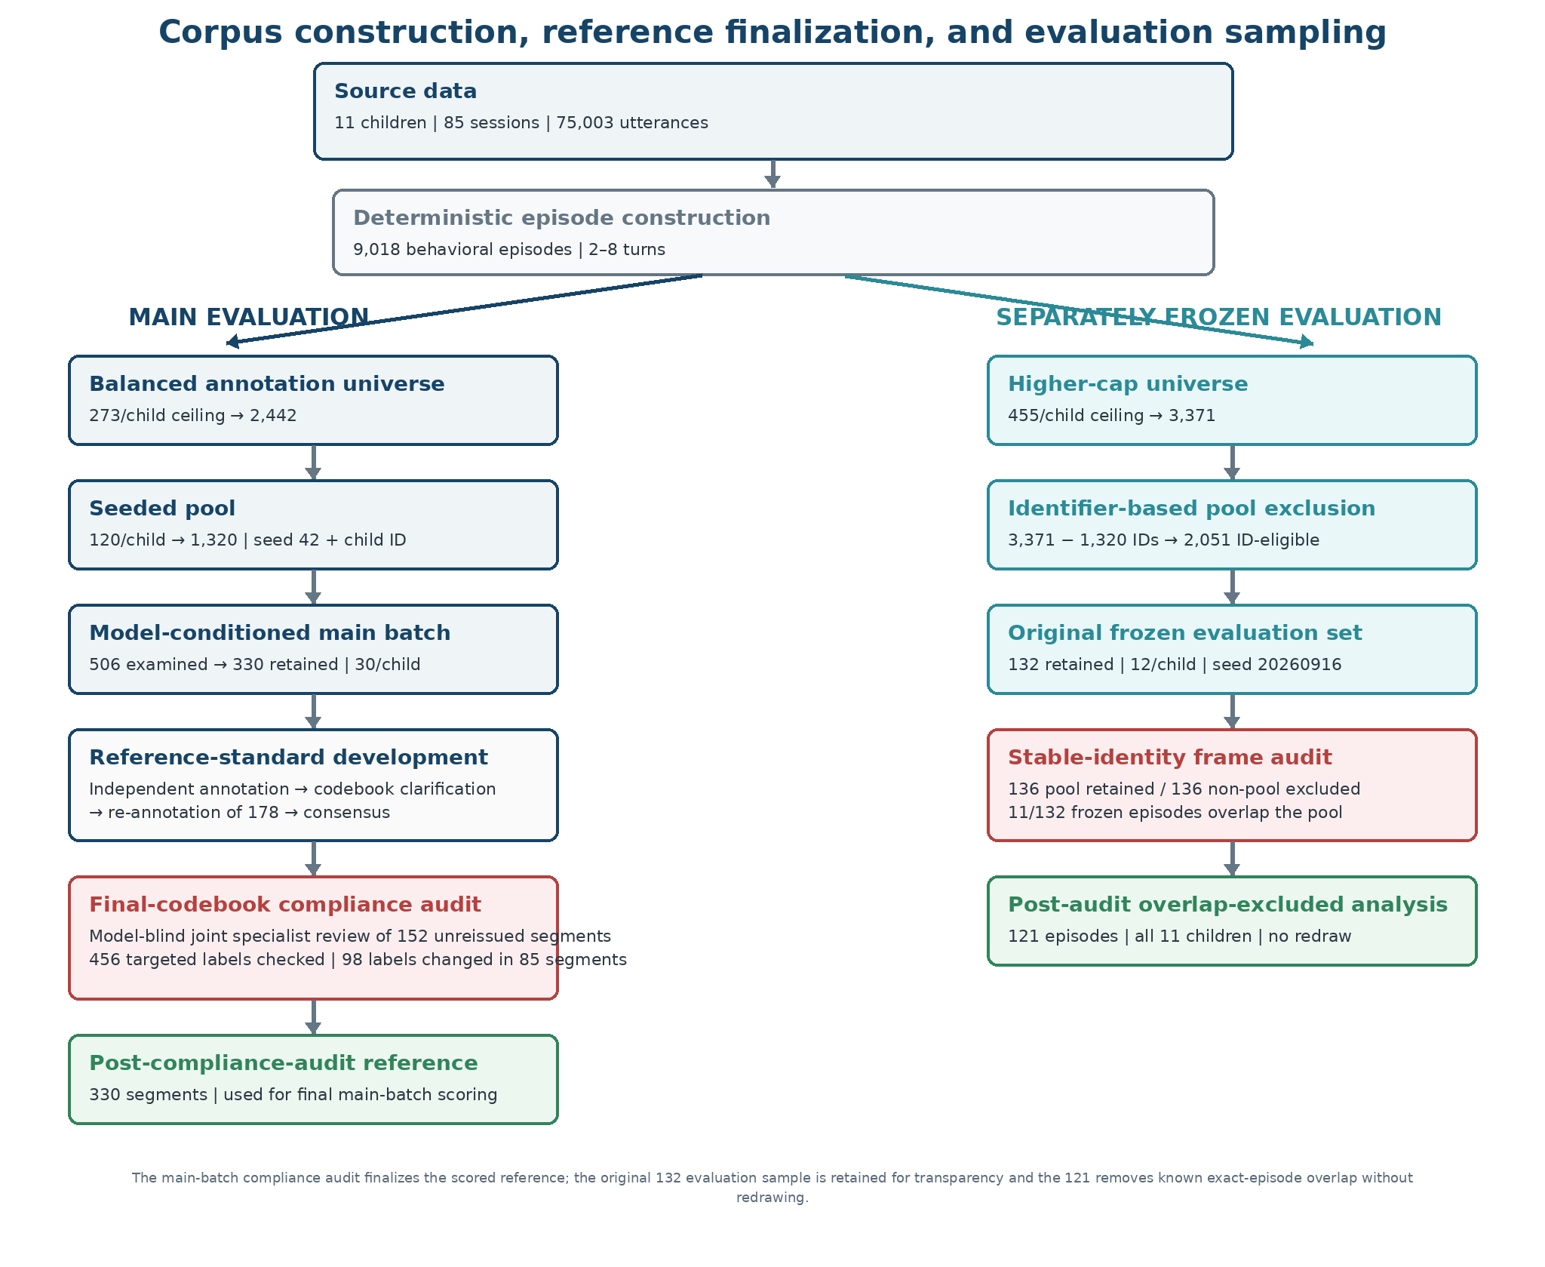
Figure 3. Corpus construction, reference-standard finalization, and evaluation sampling. The main branch uses the 2,442-segment annotation universe and a seeded, model-conditioned 330-segment batch. After independent annotation, targeted codebook clarification, re-annotation, and consensus adjudication, the 152 unreissued segments underwent a model-blind final-codebook compliance audit; the resulting post-compliance-audit reference is used for final main-batch scoring. The separately frozen 132-segment evaluation set was drawn from a higher-cap universe. Stable-identity audit found both frame distortion and 11 frozen-set pool overlaps; the sample was not redrawn. The post-audit overlap-excluded 121-segment analysis therefore remains tied to the originally frozen sampling frame, while the original 132 is retained for transparency.

2.14. Structured observation schema and evidence states
The application observation schema contains eight LLM-extracted fields: behavior, domain, duration_seconds, goal_context, modality, outcome, prompt_context, and prompt_level. Four categorical fields—domain, modality, prompt_level, and outcome—were formally evaluated using exact agreement against the adjudicated reference standard. The free-text behavior field received exploratory lexical analysis rather than comparable categorical validation. The remaining three extracted fields have no reference standard in this dataset and therefore are not described as validated. They are not consumed by the prototype analytics, adequacy routing, or deterministic report. Although the broader application schema permits them, duration_seconds, goal_context, and prompt_context were absent from all EvidencePackets used in the experimental generative-reporting evaluation.
Table 3. Structured observation fields, allowed values, and evaluation treatment.
The four categorical fields form an application-defined research schema rather than a standardized autism ontology. The schema was chosen to represent information needed by the prototype longitudinal workflow and was refined through specialist annotation and disagreement analysis. The final codebook specifies, among other boundaries, that interpersonal greetings or social exchange take precedence as social_communication when both social and language interpretations are plausible, while item requests are coded as language; gestural modality requires a communicative gesture directed toward a partner rather than ordinary object manipulation; correct or incorrect outcomes require an identifiable target and partial can represent clear progress on a multi-step target; and prompt_level reflects the highest support actually used under the codebook hierarchy. These rules are study-specific operational definitions and should not be interpreted as a universal autism-intervention taxonomy.
Field | Allowed values / form | Evaluation treatment
domain | social_communication; language; play; behavior; motor; cognitive; adaptive; sensory; null | Categorical exact-match agreement
behavior | Free text | Exploratory lexical Jaccard analysis; excluded from categorical whole-record agreement
modality | verbal; gestural; sign; aac; written; multimodal; unknown; null | Categorical exact-match agreement
prompt_level | independent; gestural; verbal; model; partial_physical; full_physical; unknown; null | Categorical exact-match agreement
outcome | correct; incorrect; approximation; no_response; partial; unknown; null | Categorical exact-match agreement
duration_seconds | Numeric/null | Not evaluated; not used operationally by analytics
goal_context | Free text/null | Not evaluated; not used operationally by analytics
prompt_context | Free text/null | Not evaluated; not used operationally by analytics

For evaluation scoring, categorical unknown is an ordinary category, whereas JSON null represents that the source supports no value. A model field that is omitted is read by the scorer as None, the same representation used for explicit model null; it is therefore not treated as a third independent scoring state. When the reference standard is null, model null is correctly_null and any populated value—including unknown—is an unsupported assertion. When the reference standard has a non-null value, model null is scored as missing output. In the analyses below, the share of all scored field slots in this latter state is termed the missed-value rate; answer-frequency interpretation uses a separate overall model-null rate. These distinctions keep missing output and unsupported assertion measurable without treating them as the same behavior.

2.15. Annotators and reference-standard development
Two anonymous autism-domain specialists participated in reference-standard development. One worked as an Intervention Specialist and the other as a Speech Therapist supporting autistic children. Both had master's-level education focused on autism-related studies and more than 10 years of relevant professional experience. Som S. Mukherjee, PhD, a mutual professional colleague of both specialists, facilitated the research team's contact with them. The specialists first completed the annotation rounds independently. Som later facilitated a joint working session in which the same two specialists reviewed the remaining disagreements and reached consensus on the final adjudicated labels. Neither Som nor the authors supervised or directed the specialists' individual annotation decisions. The specialists requested that their identities remain confidential, and their role was limited to domain interpretation and consensus adjudication rather than diagnosis, treatment recommendation, or child-outcome assessment.
The specialists were blinded to model predictions, model identity, model confidence or provider status, MARS output, and model-selection results. For each segment, the transcript cell shown to the specialists was character-for-character identical to the de-identified CHAT text supplied to the extraction models. Annotation sheets additionally contained administrative identifiers (segment, child, corpus, and session) needed to key the records, plus the codebook and blank annotation columns; they did not contain model fields. These identifiers were provided only for record management and were not permitted as evidence for assigning labels; annotation decisions were based on the displayed transcript content and the applicable codebook. Each specialist received the full material in a separately seeded row order.
Round-1 disagreement analysis identified three underspecified boundaries: whether gestural modality referred only to a communicative gesture directed toward a partner or also included ordinary object manipulation; whether correct/incorrect could be assigned when no identifiable behavioral target existed; and whether an adult utterance preceding a child response represented a prompt or merely an antecedent/opportunity. These boundaries were converted into explicit codebook rules. Domain was re-annotated alongside the treated fields but received no new rule, allowing it to function as an untreated comparator for general re-annotation or practice effects. Because these boundary refinements arose from disagreement analysis within the model-conditioned 330-segment batch, boundary discovery itself was conditioned on segments for which all three original generators produced a judgeable response. The separately sampled evaluation set subsequently tested application of the finalized rules, but additional input distributions may expose further boundary cases.
Round 1 produced 355 categorical conflicts across 215 segments. Of these, 254 conflicts fell on the three clarified boundaries and affected 178 segments. Those segments were independently re-annotated using the revised codebook in a newly randomized order and without access to the Round-1 annotations. Residual disagreements were resolved by consensus. Across the pre-compliance-audit main-batch adjudication, 182 categorical fields required a consensus decision: 89 adopted annotator A's value, 90 adopted annotator B's value, and 3 adopted a value neither had originally recorded after both recognized a codebook rule they had missed. A further 321 free-text behavior fields differed in wording and were reconciled for record completeness, producing 503 adjudicated fields in total. A subsequent model-blind final-codebook compliance audit examined the 152 segments that had not been re-issued, limited to modality, outcome, and prompt_level. All 456 targeted labels were checked against the final clarified rules; 98 labels across 85 segments were changed (14 modality, 20 outcome, and 64 prompt_level). The returned worksheets were identical and are therefore treated as one joint specialist audit rather than two independent audit passes. Domain and behavior were outside this targeted audit. The resulting post-compliance-audit reference standard is used for all final main-batch generator and MARS scoring reported below; the earlier adjudicated reference is retained as provenance.
For the original frozen 132-segment evaluation set, both specialists used the final codebook from the first segment. The 133 adjudicated differences comprised 102 free-text behavior wording differences, 14 conflicts directly covered by an existing codebook rule, and 17 genuine categorical judgment calls. The consensus outcome adopted annotator A's returned value for 54 rows and annotator B's for 79. This asymmetry is reported as a limitation rather than interpreted as a stable difference between annotators. The later 121-segment overlap-excluded analysis uses the same already-adjudicated reference records after removing the 11 overlapping episodes; no labels were changed in response to model results.

2.16. Annotation reliability and statistical analysis
Cohen kappa was calculated separately for each categorical field, treating explicit null as a category [17]. Fields were not pooled for kappa because they use different vocabularies. Maximum attainable kappa under the observed marginal distributions was also calculated to distinguish disagreement caused by incompatible category usage from disagreement within a shared vocabulary [23].
Because multiple segments came from each child, primary reliability confidence intervals used 10,000-replicate child-cluster percentile bootstraps: each replicate sampled 11 children with replacement and retained all segments belonging to each sampled child; the 2.5th and 97.5th percentiles formed the interval (seed 20260915). A replicate with undefined kappa because only one category remained after resampling was dropped. Segment-level percentile intervals were retained as a sensitivity analysis. Paired changes in kappa on the 178 re-issued segments are reported descriptively alongside the unchanged domain comparator; because the re-issued set was disagreement-enriched and the same specialists annotated it twice, those changes do not isolate a causal codebook effect. MARS selector comparisons use 10,000-replicate child-cluster paired bootstraps on the 142 genuinely reranked segments: children are resampled with replacement, all eligible reranked segments for each sampled child are retained, and both policies are scored on the same resample. Model-performance intervals use the same 10,000-replicate child-cluster percentile procedure, with seed 20260926. With only 11 child clusters, all child-cluster bootstrap intervals in this study are interpreted as descriptive uncertainty summaries rather than well-calibrated confirmatory inference. Across the 28 kappa-related child-cluster intervals recorded for the annotation analyses, each requested 10,000 replicates; 24 retained all 10,000, while four modality-related intervals dropped only 1-3 replicates (0.01%-0.03%) because the resample collapsed to a single category and kappa was undefined. All 10,000 replicates were valid for every reported interval on the post-audit overlap-excluded 121-segment model-performance analysis. Full kappa replicate accounting is provided in Supplementary Material 5.
The reported mean kappa of 0.801 is an unweighted mean of the four per-field kappas recomputed across all 330 paired pre-adjudication annotations: Round-2 values for the 178 re-issued segments and retained Round-1 values for the remaining 152. The four kappas were 0.718 for domain, 0.911 for modality, 0.831 for prompt_level, and 0.743 for outcome. The 152 unreissued segments already had high Round-1 mean kappa (0.884), so 0.801 is a mixed paired pre-audit reliability descriptor rather than a before-versus-after estimate or a reliability estimate of the later corrected gold standard. The subsequent joint final-codebook compliance audit of those 152 segments was not an independent paired annotation round and therefore does not generate a new kappa estimate. The more direct descriptive reliability comparison remains the change within the 178 disagreement-enriched segments; even there, familiarity and round effects may contribute.

2.17. Locally served LLM extraction evaluation
No model was trained, fine-tuned, LoRA/QLoRA-adapted, or otherwise updated using the annotation dataset. All generators were pretrained instruction-tuned checkpoints used with prompts only; the human annotations were used after generation to construct the reference standard and score outputs.
Table 4. Locally served models and their roles in the extraction and MARS evaluations.
Role | Model | Approx. size | Quantization | Context
Generator | Llama 3.2 (digest a80c4f17acd5) | 3.2B | Q4_K_M | 131,072
Generator | Qwen 2.5 3B (357c53fb659c) | 3.1B | Q4_K_M | 32,768
Generator / designated final-build extractor | Qwen 2.5 7B (845dbda0ea48) | 7.6B | Q4_K_M | 32,768
Generator added after original MARS; judge in MARS | Qwen 3 14B (bdbd181c33f2) | 14.8B | Q4_K_M | 40,960
Judge only | Mistral (6577803aa9a0) | 7.2B | Q4_K_M | 32,768

All models were served locally with Ollama 0.33.3 on one Apple M5 Pro system (15 cores, 24 GB unified memory, macOS 26.6.2, Python 3.12.12). One runtime reduced hardware confounding. The extraction prompt (version 1.0.0) specified the target fields and values and instructed models to use null when unsupported, not fabricate or infer beyond the source, avoid diagnostic/treatment/causal claims, and prefer abstention to invention. Each extraction used one forced record_observation tool call. Temperature, top_p, top_k, token limit, and generation seed were not explicitly set and therefore used server defaults where applicable. Raw generation is not bit-reproducible; the original outputs were preserved and replayed for all downstream analyses. Generator comparisons in this paper are therefore single-run preserved-output comparisons rather than evidence of ranking stability across repeated stochastic generations.
The timing of reference-standard refinement is important for interpreting extraction performance. The preserved Llama 3.2, Qwen 2.5 3B, and Qwen 2.5 7B outputs used for the main batch were generated on 7 September 2026 with extraction prompt version 1.0.0. The three specialist clarifications described in Section 2.15 were formalized on 15 September, after those outputs had been produced. Prompt version 1.0.0 did not explicitly encode the clarified distinctions between communicative gesture and ordinary object manipulation, identifiable-target requirements for outcome coding, or prompt versus antecedent/opportunity. Qwen 3 14B was generated on 16-17 September with the same prompt, forced tool schema, and categorical value sets; although the human codebook then existed, its clarified rules were not added to Qwen 3 14B's model-visible instructions. Accordingly, all reported generator scores evaluate the original prompt/schema condition against the subsequently stabilized human reference standard; a final-codebook-aware extraction condition was not tested.
The frozen research request path is intended to use Qwen 2.5 7B with extraction prompt version 1.0.0, the same historical prompt condition evaluated in the preserved-output experiment. That prompt does not encode the three later specialist clarifications, so the frozen research build should not be interpreted as a final-codebook-aware extraction condition. This choice preserves alignment with the evaluated condition; mandatory professional verification remains required before any AI-derived record can enter analytics. Any later prompt that explicitly incorporates the finalized modality, outcome, and prompt-level definitions will constitute a new extraction condition requiring separate evaluation. A subsequent repository audit found that the default configuration still pointed to llama3.2:latest rather than Qwen 2.5 7B. This implementation/configuration mismatch does not change the preserved component-evaluation results, but it must be aligned and confirmed by the final governance-critical end-to-end verification before submission. No reported result was recomputed under a newer extraction prompt.
For the component experiment, every model received the same de-identified CHAT episode text: the full 2-8-turn window with speaker labels and the retained %spa, %act, and %gpx tiers. The prompt contained no child or corpus identifier, no session identifier or timestamp, no intervention goal, and no clinical context. Request-side administrative metadata were used only to label the returned research record and were not rendered into the model prompt. This research input is therefore narrower than the richer app-known context available in the prototype workflow. The specialists annotated the identical transcript text, with administrative identifiers visible only for sheet management as described above.
Evaluation used the four categorical fields only for exact scoring. For each field, agreement was (correct + correctly_null) divided by all scored segments. Merged categorical agreement was the unweighted mean of those four field-specific agreements. Whole-record agreement was the proportion of segments for which all four categorical fields were correct or correctly_null. Missed-value rate was the share of all scored field slots in which the reference standard recorded a value and the model returned null or omitted the field. The null rate on answerable fields used only reference-populated slots as its denominator, while overall model-null rate counted model null or omission across all scored slots regardless of the reference. Unsupported assertion was pooled across the four fields as hallucinated divided by (hallucinated + correctly_null), so its denominator contains only reference-standard null opportunities. This pooled quantity is an opportunity-weighted rate, not an unweighted mean of four field-specific percentages; fields with more reference-null opportunities contribute more to the pooled value. Categorical unknown was scored as an ordinary value; omitted output and explicit model null were both read as None. Behavior was evaluated separately using Jaccard similarity over lowercased whitespace-delimited word sets and was not included in whole-record categorical agreement. Final main-batch results use the post-compliance-audit reference standard; generator outputs were preserved and rescored without regeneration. The frozen 132/121 evaluation branch uses its separate already-adjudicated reference and is unchanged by the main-batch audit.
Before any reference labels existed, the study code specified a single-generator prototype baseline chosen by highest agreement on the adjudicated main batch. Qwen 2.5 7B ranked first when the original 330-segment batch was scored under both whole-record and merged mean categorical agreement; Qwen 3 14B was added to the scored roster afterward. After the final-codebook compliance audit and rescoring of the same preserved outputs, Qwen 2.5 7B remained first on merged agreement (41.3%, versus 40.3% for Qwen 3 14B, 32.0% for Llama 3.2, and 20.8% for Qwen 2.5 3B). Qwen 2.5 7B is therefore the extractor designated for the final frozen research prototype build under the original agreement-based rule, not a globally superior or safest model. The original frozen 132-segment evaluation set and the later overlap-excluded 121-segment analysis were used only for subsequent assessment and did not revise that selection. A subsequent repository audit found that the repository default still pointed to Llama 3.2; final configuration alignment to the designated Qwen 2.5 7B path remains a pre-submission verification item. The frozen research build retains prompt version 1.0.0 rather than silently substituting an unevaluated final-codebook-aware prompt.

2.18. Offline MARS multi-judge reranking experiment
MARS, the study's offline multi-judge candidate-reranking procedure, was evaluated as a per-segment candidate-selection experiment and is not part of the operational request path. The candidate roster comprised the original three generators: Llama 3.2, Qwen 2.5 3B, and Qwen 2.5 7B. Qwen 3 14B was added later as a generator for scoring against the same reference standard and served as a judge in the reported MARS run, but it did not contribute candidates; no four-generator MARS result is reported.
At runtime, reviewable candidates required SUCCESS or PARTIAL provider status, at least one observation, and at least behavior or domain populated. Candidate deduplication used a deterministic hash over normalized structured fields. Zero reviewable candidates caused abstention; one candidate short-circuited without judging; two or more triggered reranking. A model was ineligible to judge a segment if it had generated any candidate for that segment. Judges saw the source transcript and anonymous candidate records but not generator identity, generator confidence/status, the annotation codebook, gold labels, or other judges' rankings.
The reported MARS experiment is therefore a deliberately codebook-naive LLM-as-judge condition: judges ranked candidates from the source text without being given the task-specific rules that shaped the human reference standard. This tests whether generic model judges can recover candidate quality from the source alone; it should not be interpreted as the performance ceiling of codebook-aware multi-judge selection. A codebook-aware selector condition remains a future experiment.
The reported judge roster comprised Llama 3.2, Qwen 2.5 3B, Qwen 2.5 7B, Mistral, and Qwen 3 14B. Exact model identity was excluded whenever that model had generated a candidate for the segment; same-family overlap was permitted. After this self-judge exclusion, 124 of the 165 rerank-required segments had three eligible judges and 41 had two. This ensured at least two eligible judges for every segment that entered the reported reranking stage.
Valid rankings were combined with reciprocal rank fusion, score(c)=sum_j 1/(60+rank_j(c)). The provisional winner then had to be among the judges' modal first choices, avoid a modal tie, and receive first-choice support of at least 0.5. The 0.5 threshold was a configured prototype value and was not empirically calibrated or tuned on the evaluation set. With two judges, a 1-1 split therefore abstained before the threshold was applied. The selected output had to remain one intact candidate; field-wise blending was not allowed. MARS used no gold labels while judging. Gold labels were used only afterward to evaluate the selector.
Judge inference used temperature 0, a 2,048-token output budget, disabled internal thinking where supported, and one generation per judge per segment. The reported run recorded per-judge parsing/discard rates, with a maximum discard rate of 1.8%.
A preliminary run using a 256-token judge budget was discarded after Qwen 3 14B exhausted the available budget during reasoning and failed to emit a parseable ranking on all 165 rerank-required segments. The affected run is retained only as provenance and is excluded from every reported MARS result; the reranking experiment was repeated with the corrected 2,048-token budget.
MARS performance is reported at two distinct levels. Full-policy evaluation covers all 330 main-batch segments and pairs coverage with whole-record agreement; abstentions count as failures for accuracy_over_all, while accuracy_over_returned is conditional on MARS returning a record. A separate selector-quality analysis is restricted to the 142 segments on which a genuine usable reranking decision occurred and compares field-level selection quality among MARS, a strongest-generator policy, and random candidate choice. For that selector analysis, the random comparator is the analytical expected agreement of a uniform choice among the distinct reviewable candidates actually available to MARS for each segment; no random draw or seed is required. The strongest-generator comparator uses Qwen 2.5 7B when it has a reviewable candidate and otherwise falls back to the next reviewable generator in the fixed main-batch agreement order Qwen 2.5 7B > Llama 3.2 > Qwen 2.5 3B. Although the rule for using the highest-agreement generator was specified prospectively, the winning generator and fallback ordering were determined from the same 330-segment main-batch reference labels that contain the 142 reranked cases. This strongest-generator comparator is therefore an in-sample, data-selected benchmark rather than an independently selected policy. These analyses answer different questions and are not pooled.
The final reported three-generator whole-record oracle ceiling is defined over all 330 main-batch segments and all preserved outputs from Llama 3.2, Qwen 2.5 3B, and Qwen 2.5 7B, regardless of provider SUCCESS, PARTIAL, or abstained status. No MARS reviewability filter or candidate deduplication is applied. A segment is oracle-correct when at least one of the three preserved outputs exactly matches the post-audit reference on all four categorical fields, including correct null handling; free-text behavior is not part of the criterion. Under the post-compliance-audit reference this yielded 12/330 segments (3.6%), compared with 20/330 (6.1%) under the pre-audit reference.

2.19. Experimental generative reporting evaluation
The experimental reporting model was Qwen 2.5 7B served through Ollama's native /api/chat endpoint with an 8,192-token context and native JSON-schema constrained decoding. Eleven child-level EvidencePackets were constructed from the then-adjudicated pre-compliance-audit reference fields together with corpus-derived and synthetic administrative metadata and passed through the prototype adequacy router and analytics engine. Within the structured records, behavior, domain, modality, prompt_level, and outcome came from those human reference records; child_id and session_id came from corpus structure; setting and contributor_role were deterministically derived from corpus membership (Rollins: clinic/interventionist; Flusberg: home/parent); observation_date was synthetic, assigned one week per session in session order beginning 5 January 2026; and record_id and version were synthetic identifiers, with version fixed at 1. The review period began at the earliest synthetic observation date for each child and ended at that child's latest synthetic session date. All 11 packets had an empty active-goal list (goals=[]); consequently no record-to-goal mapping was used, and the goal-coverage check passed with the deterministic state 'No active goals defined'. The unevaluated fields duration_seconds, goal_context, and prompt_context were absent from all packets. No structured-record value in the reporting experiment came from model extraction output. Because the corpus-derived metadata contained only one setting and one contributor role per child, every packet was classified as limited and cross-setting and cross-contributor comparisons were deliberately withheld. The experiment therefore tests one recurrent limited-evidence governance pattern; it does not establish reporting behavior for adequate packets, insufficient packets, full-analytics abstention, active-goal conditions, or other combinations of withheld analyses. The later final-codebook compliance audit did not rerun this historical reporting experiment.
The historical reporter prompt and constrained schema were not fully aligned. The prompt instructed the model to 'Return a JSON array of report sections', whereas the constrained schema required a top-level object containing a required sections array. The prompt described an abstention_note for each section and instructed the model to preserve abstention messages and state when evidence was 'insufficient or limited', but the schema made abstention_note optional and provided no mandatory per-KPI withholding structure. The prompt also did not explicitly require enumeration of every withheld KPI by name. These historical prompt/schema details are preserved exactly in Supplementary Material 4 rather than silently corrected after the result.
Reconstructed model-visible input lengths, using the Qwen 2.5 tokenizer and the same chat-template text, ranged from 7,416 to 8,009 tokens across the 11 cases (median 7,462). Every complete serialized EvidencePacket, including both withholding objects, fit within the configured 8,192-token input window. However, this left only 183-776 tokens of nominal context headroom for generated output, no num_predict/output-token limit was set, and neither output-token counts nor the generated report text were preserved. The run set the model, structured JSON schema, context length, stream=false, one generation per child, and a 600-second timeout; temperature, top_p, top_k, repeat penalty, output limit, and seed were not explicitly set and therefore used unrecorded server defaults. The Ollama server version at run time was not preserved. Thus input truncation of the EvidencePackets can be ruled out from the reconstructed inputs, but complete generated-output fit within the effective context cannot be established from the saved artifacts. The retained result artifact, reporting_groundedness.json, stores validation outcomes, error messages, and scoring information rather than the primary generated report texts; consequently the original 0/11 governance result cannot be independently recomputed from preserved primary model outputs.
A deterministic validator checked four classes of report failure: prohibited diagnostic, treatment, causal, prognostic, deficit/normality, or autonomous goal-modification language; acknowledgement of insufficient evidence when applicable; acknowledgement of every withheld KPI; and numeric traceability/evidence-reference validity. For a withheld KPI, the validator searched section body text only and counted it as acknowledged if any body contained the KPI name with underscores replaced by spaces or the substring 'withheld' or 'insufficient'. It did not accept the prompt's word 'limited' by itself and did not inspect headings, evidence_refs, or the optional abstention_note field. This creates a further historical mismatch between the prompt/schema and the lexical validator. The numeric check required each printed numeric assertion to match a value present somewhere in the EvidencePacket at the same printed precision; it did not independently verify that the number was associated with the corresponding KPI or field in the generated narrative. Evidence references had to resolve to an allowed identifier; successful resolution did not establish semantic entailment between a narrative statement and the referenced record. The reporting validator validate_report() in src/backend/ml/reporting_client.py was introduced in commit 75eb1d5 on 25 August 2026; the numeric/evidence-reference scorer in tests/eval/reporting/groundedness.py was introduced in commit 7a4b725 on 16 September 2026; and the artifact recording the 11 model-generated reports' validation/scoring results was committed as 9ecc330 on 17 September 2026. The validator logic was unchanged across those versions. The prohibited-content check used six case-insensitive regular-expression families over section body text only: diagnosis language; recommendation language coupled with therapy/treatment/intervention/medication; causal language coupled with autism/ASD/condition; prognosis/outlook or 'will likely/probably'; normal/abnormal/delayed/deficit language; and change/modify/adjust coupled with goal/objective/target. The exact expressions and implementation details are reproduced in Supplementary Material 4. Because raw generated report text was not archived, 'recorded reports' in this study refers to the retained validation/scoring records, not preserved report prose. No prompt remediation or second generative run was performed after the 0/11 validation result; the tested contract failure was preserved and the generative layer was removed from the operational path.

2.20. Controlled-environment functional verification
The application includes workspace creation, goal management, contributor invitation/revocation, role-scoped access, schedule configuration, natural-language observation capture, clarification, structured extraction, correction/versioning, overdue-state handling, adequacy routing, full/partial abstention, deterministic metrics, reporting, evidence drill-down, and audit history. Multiple rounds of manual end-to-end testing were completed during development and were used to correct defects until the tested flows operated as expected in the controlled environment. These tests were development verification rather than an independent usability, security-certification, or clinical-effectiveness study. The complete automated test suite will be linked from the frozen study repository in the Supplementary Materials rather than enumerated in the main article.
Authorization claims were also checked directly in the backend test suite. On 26 September 2026, 120 tests across 10 authorization-relevant suites passed with no failures. The tested conditions included contributor confinement to an assigned child, inability of contributors to create or edit professional goals, inability of contributors to verify or correct structured evidence, immediate loss of access after revocation, and denial of professional analytics/report access to unauthorized users. Four real-database integration tests covered cross-child confinement, contributor goal modification, revocation using a previously issued token, and unrelated-professional access; the remaining suites included endpoint-level role checks. These results support the claimed behavior under the tested conditions but are not presented as a security certification.
The final controlled end-to-end verification is intentionally limited to governance-critical invariants that support claims made in this paper. It will confirm the complete studied extractor configuration, not only the model name: Qwen 2.5 7B together with the intended model digest/version, extraction prompt version 1.0.0 or its hash, and tool/output schema version or hash. The recorded prompt condition is intentionally the historically evaluated condition rather than an unevaluated final-codebook-aware prompt. The run will also confirm that an unverified AI-derived record cannot enter longitudinal analytics; an intervention specialist can verify or correct the record before it becomes analytics-eligible; corrected evidence propagates to downstream calculations while the immutable original source remains preserved; evidence withheld by the adequacy router remains explicitly withheld in the deterministic operational report; and a displayed KPI or report item can be traced through its structured-evidence identifier/version to the immutable source observation. The traceability check will be repeated after a correction/version change to verify that the displayed result points to the corrected structured version while preserving the linkage to the original source observation and prior version.
[TO COMPLETE BEFORE SUBMISSION: Insert the final governance-critical end-to-end verification result: application commit/release, test date and controlled test-data type; selected extractor model name and digest/version; extraction prompt version/hash; tool/output schema version/hash; pass/fail results for the governance-critical invariants above, including KPI/report-item drill-down from displayed result to structured evidence identifier/version and immutable source observation before and after a correction/version change; and any defect found and corrected before the frozen run. Update Results and Limitations with the final outcome. The full automated test suite will be referenced through the frozen GitHub/archival release in Supplementary Material 7.]
Generative AI tools were also used during prototype implementation, technical ideation, and evaluation-tooling development. These tools did not create, modify, select, or adjudicate reference-standard labels, and reported quantitative results were computed from recorded study artifacts. Human authors remained responsible for study design, implementation review, interpretation, and scientific conclusions.

2.21. Ethics, data protection, and reproducibility
The model-evaluation data are archival ASDBank/TalkBank corpora collected by third parties and accessed under the repository's registered-user terms. No child was recruited or contacted for this study, and no care was delivered, changed, or withheld on the basis of any system output. The two intervention specialists generated human annotation data used to construct and evaluate the coding/reference-standard process. Their formal status for research-ethics purposes is not assumed by the authors and will be reported exactly as determined by the reviewing institution.
[TO COMPLETE BEFORE SUBMISSION: Insert the final ethics/IRB determination exactly as issued, including reviewing institution, protocol/reference number, date, and the determination for (1) archival ASDBank child corpora, (2) specialist annotation/adjudication, and (3) any human involvement in application testing. The manuscript will not be submitted until this determination is complete.]
Reproducibility is artifact-based. The recorded evaluation state is associated with repository commit 6163d1306049c401ed0b25bf8c6d2bc986f40194; the mandatory VERIFIED/CORRECTED analytics gate and deterministic operational reporter were introduced together in commit 63a73a61fd96c7c6b5738f682f8c0c6ae86ddb2b. The model-blind final-codebook compliance audit of the 152 unreissued main-batch segments was recorded with the returned worksheets in commit 60c4704, and the resulting post-compliance-audit reference was used to regenerate all dependent main-batch scoring artifacts from preserved generator/MARS outputs without new model inference. For the historical reporting experiment, the governance validator was introduced in commit 75eb1d5 (25 August 2026), the numeric/evidence-reference scorer in 7a4b725 (16 September 2026), and the 11-report validation/scoring artifact in 9ecc330 (17 September 2026); the relevant validator logic was unchanged across that chronology. The environment used Python 3.12.12 and Ollama 0.33.3 with a dependency lock. Fixed recorded seeds were used for sampling, bootstrap analyses, and the MARS run; generator inference itself did not use a generation seed, so preserved outputs are replayed rather than regenerated for reported downstream analyses. The historical reporter result artifact preserves validator scores/errors but not the generated report prose, so the 0/11 reporting result is not independently recomputable from primary generated outputs. The final Qwen 2.5 7B research build will be identified by the frozen study release after end-to-end verification.
Because ASDBank is password-protected, transcript-derived text will not be placed in the public release. The planned reproducibility package uses a clean public GitHub repository archived on Zenodo. Public artifacts will include source code after corpus-text audit, schemas, prompts, the annotation codebook with synthetic rather than source-text examples, adequacy and analytics rules, reporting definitions, evaluation scripts, MARS code/configuration, artifact hashes, aggregate metrics, categorical reference labels and per-segment scoring verdicts keyed by opaque or hashed identifiers, and scripts that allow authorized ASDBank users to regenerate the exact segment sets and verify them against published hashes. Free-text behavior labels, adjudication rationales, transcript-containing files, and frozen outputs that reproduce source text will remain subject to ASDBank access restrictions. [TO COMPLETE BEFORE SUBMISSION: insert the clean repository URL, immutable release tag, Zenodo version DOI, and final code/documentation licenses.]

3. Results

3.1. Application implementation and the final governance boundary
The controlled-development build implements the longitudinal workflow as an integrated application rather than as a collection of isolated model experiments. The implemented path spans professional workspace and goal setup, child- and role-specific contributor access, goal-linked observation expectations, conversational free-text capture, configurable local extraction, professional verification or correction, versioned evidence storage, adequacy and representation routing, deterministic analytics, a professional dashboard and deterministic report, evidence drill-down, and audit history. Qwen 2.5 7B is designated for the final frozen research extraction build under the pre-specified agreement rule and the historically evaluated prompt-v1.0.0 condition; the build is therefore not presented as a final-codebook-aware extractor. A subsequent repository audit found that the default configuration still pointed to Llama 3.2; model/configuration alignment and the final governance-critical end-to-end run therefore remain pending and will be completed before submission. The implementation findings reported here describe the completed controlled-development architecture and its backend-enforced boundaries.
The controlled-development application implemented the planned longitudinal workflow. During final architecture review and implementation audit, one important defect was identified: records marked VALIDATED by deterministic schema checks could reach analytics without a human having read the structured interpretation. This defect was corrected by introducing a separate VERIFIED state and tightening analytics eligibility to VERIFIED or CORRECTED records only. The distinction is consequential: validation establishes formal conformance, whereas verification represents professional review of meaning.
The operational reporting path was also changed after component evaluation. The generative reporter remains available only as an experimental mode; the default report is deterministic. These two changes make the final operational architecture more conservative than the original design: generative models propose structure and can be studied for narrative reporting, but unverified model structure and governance-failing generated prose do not enter the operational longitudinal interpretation path.
The targeted authorization suite described in Methods also passed 120 of 120 tests across 10 suites, including real-database checks for cross-child confinement and immediate revocation. These results provide implementation evidence for the child- and role-scoped access claims under the tested conditions; they do not establish comprehensive system security.

3.2. Corpus and annotation reliability
Parsing and segmentation produced 9,018 behavioral episodes from 11 children and 85 sessions. The deterministic 273-per-child balanced selection retained 2,442 segments for the annotation universe. The seeded main-pool procedure examined 506 of 1,320 pool segments to obtain the model-conditioned 330-segment batch (30 per child). A higher-cap selection produced 3,371 segments and the original builder froze 132 evaluation segments (12 per child) after identifier-based pool exclusion. Stable-identity audit showed that the original exclusion frame wrongly retained 136 pool episodes and excluded 136 non-pool episodes (6.6% of the intended frame), with uneven child-level distortion, and that 11 of the frozen 132 overlapped the original pool. The original 132 are retained for transparency; the post-audit overlap-excluded 121, still spanning all 11 children, are analyzed without redrawing the frozen sample.
Table 5. Round-1 categorical annotation reliability. Confidence intervals use child-cluster bootstrap resampling.
Field | Round-1 kappa | 95% CI | Maximum attainable kappa | Observed / maximum
Domain | 0.751 | 0.704-0.790 | 0.921 | 0.816
Modality | 0.570 | 0.434-0.696 | 0.622 | 0.916
Prompt level | 0.595 | 0.519-0.675 | 0.839 | 0.709
Outcome | 0.524 | 0.467-0.577 | 0.758 | 0.691

Round-1 mean kappa across the four categorical fields was 0.610. Most categorical conflicts mapped to the three codebook boundaries identified during disagreement analysis. On the 178 disagreement-enriched re-issued segments, modality changed from 0.385 to 0.866 (change +0.481; child-bootstrap 95% CI 0.337-0.583), prompt_level from 0.281 to 0.574 (+0.293; 95% CI 0.191-0.435), and outcome from 0.284 to 0.628 (+0.344; 95% CI 0.160-0.562). The unchanged domain comparator changed from 0.732 to 0.691 (-0.041; 95% CI -0.142 to 0.068). These paired changes are descriptive rather than a causal estimate because the 178 were selected for disagreement and were coded twice by the same specialists. Across all 330 segments in their paired pre-audit state—Round-2 labels for the 178 re-issued segments and retained Round-1 labels for the remaining 152—the per-field kappas were 0.718, 0.911, 0.831, and 0.743, giving an unweighted mean of 0.801. The 152 retained segments already had Round-1 mean kappa of 0.884, so 0.801 should not be read as a clean 0.610-to-0.801 before-versus-after codebook effect or as reliability of the later corrected reference. In the subsequent model-blind joint final-codebook compliance audit of those 152 segments, all 456 modality/outcome/prompt_level labels were checked and 98 labels in 85 segments were corrected: 14 modality, 20 outcome, and 64 prompt_level. Ninety-seven of the 98 changed labels had originally been agreed by both annotators in Round 1 and one had previously been adjudicated. Because the returned audit worksheets were identical, this was a joint compliance audit rather than a new independent reliability round; the kappa estimates above are therefore retained only as pre-audit reliability descriptors, while the corrected labels define the final post-compliance-audit main-batch reference standard. With only 11 child clusters, the child-cluster intervals are descriptive uncertainty summaries; interval-by-interval bootstrap validity counts are reported in Supplementary Material 5.
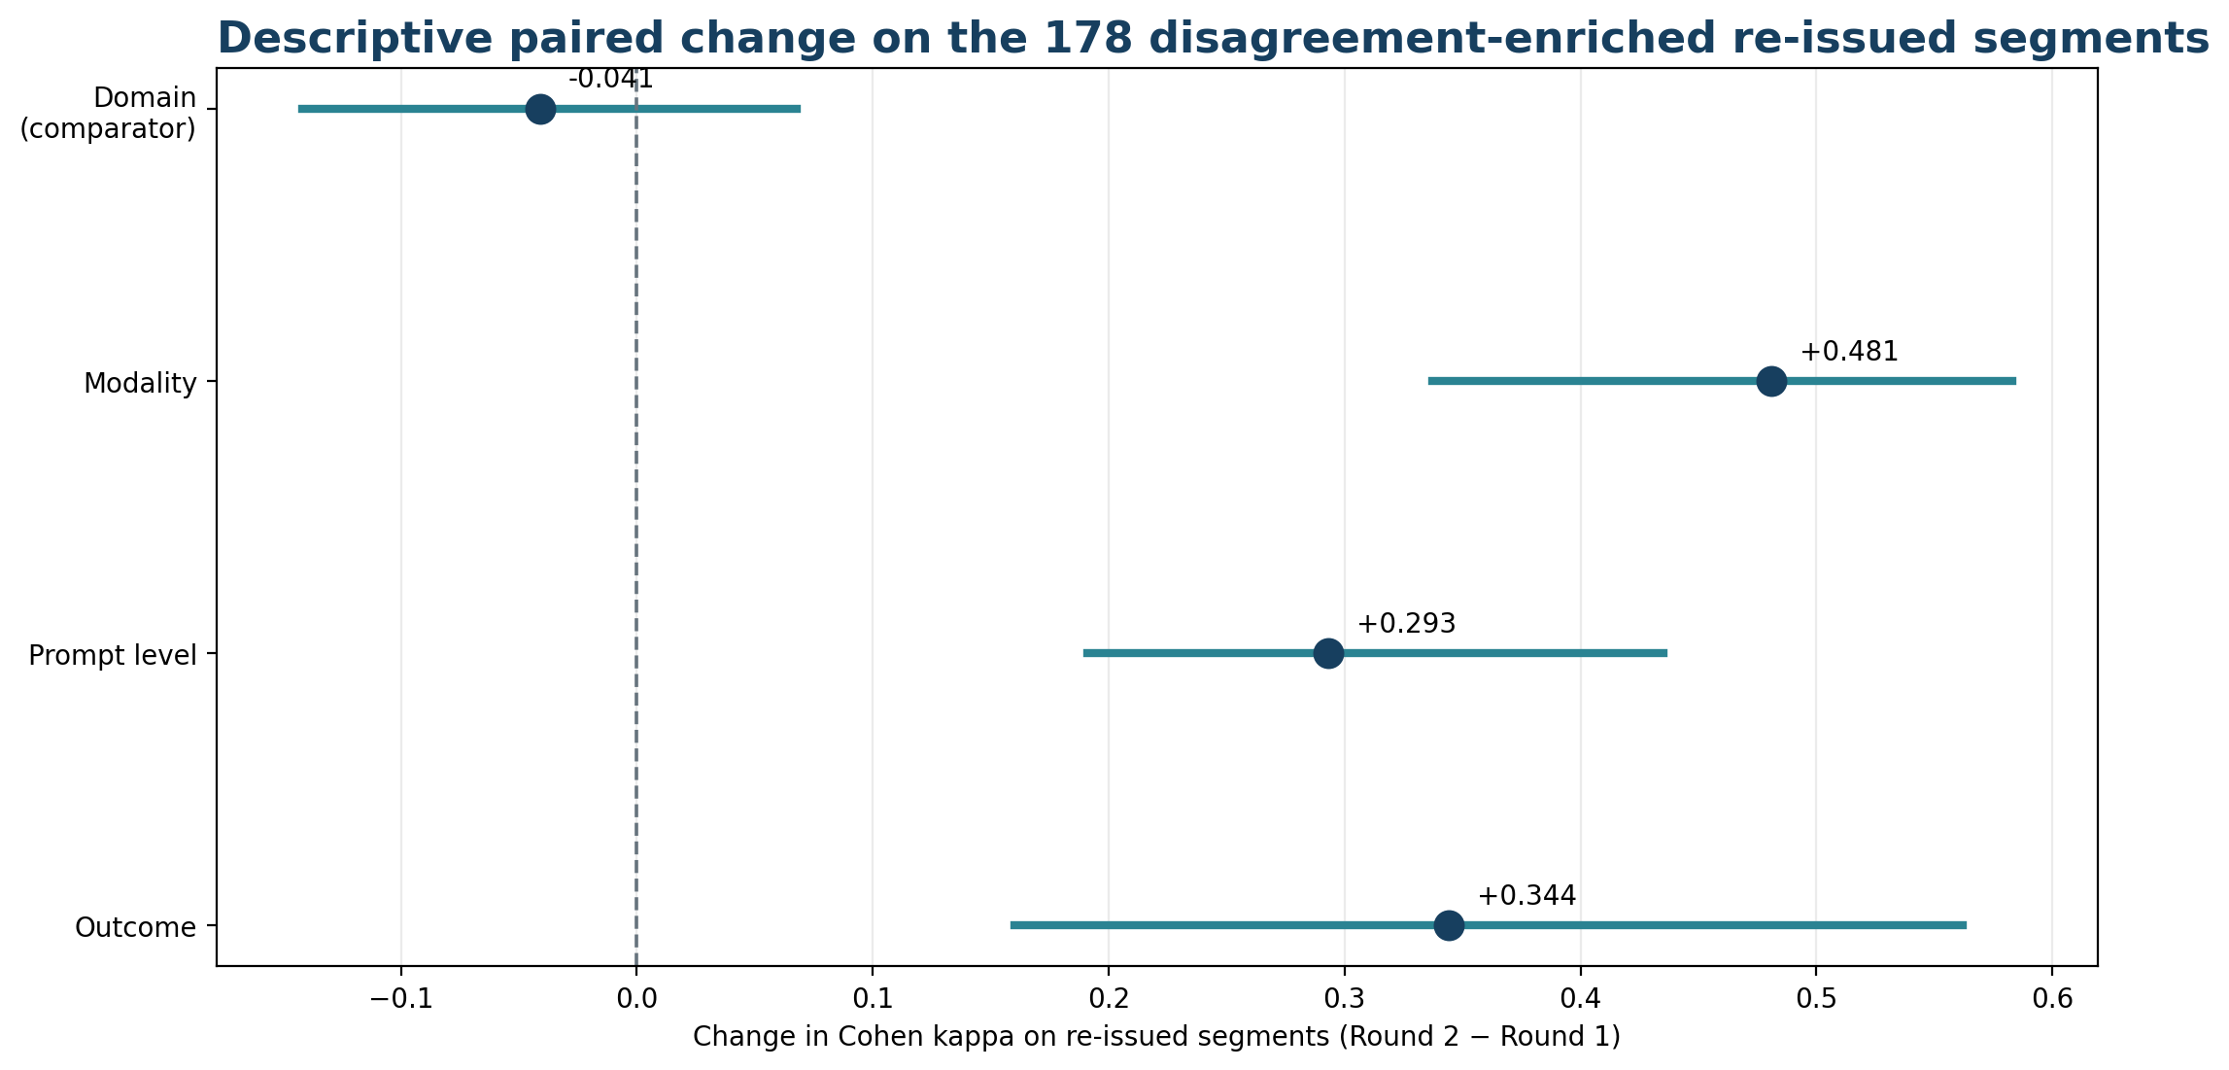
Figure 4. Descriptive paired change in Cohen kappa on the 178 disagreement-enriched segments that were re-issued after codebook clarification. Domain received no new rule and serves as an internal comparator. The changes do not isolate a causal codebook effect because the same specialists re-annotated a selected subset.
On the original frozen 132-segment evaluation set, the first pass within the frozen evaluation annotation round produced kappa values of 0.879 for domain, 0.929 for modality, 0.916 for prompt_level, and 0.914 for outcome, for a mean of 0.910. Because one episode in the frozen 132 also entered the 330 main batch, "first pass" here refers to the evaluation annotation round rather than guaranteeing first exposure to every individual episode. Recomputing pre-adjudication reliability on the post-audit overlap-excluded 121 episodes yielded kappas of 0.900 for domain (95% child-cluster CI 0.814-0.963), 0.932 for modality (0.799-1.000), 0.944 for prompt_level (0.854-1.000), and 0.927 for outcome (0.894-0.959), for an unweighted mean of 0.926. The small increase from 0.910 to 0.926 leaves the reliability interpretation essentially unchanged. These evaluation-round results remain separate from the disagreement-enriched Round-2 comparison and do not isolate codebook effects from accumulated annotator experience. Removal of overlapping episodes did not alter the already-adjudicated labels of the retained records.

3.3. Model-conditioned versus evaluation-set extraction agreement
Table 6. Generator agreement and unsupported-assertion behavior on the model-conditioned main batch, the original frozen 132-segment evaluation set, and the post-audit overlap-excluded 121-segment analysis. Values in brackets are 95% child-cluster percentile bootstrap intervals. The 121-set intervals use 10,000 replicates with seed 20260926; all 10,000 replicates were valid for every reported 121-set interval.
Generator | Main merged agreement [95% CI] | Frozen 132 merged agreement [95% CI] | Post-audit overlap-excluded 121 merged agreement | Main unsupported assertion [95% CI] | Evaluation unsupported assertion
Llama 3.2 | 32.0% [25.2-38.3] | 26.5% [20.8-31.6] | 27.5% [21.7-32.7] | 83.4% [79.6-86.6] | 132: 84.1% [77.6-91.5]  121: 83.0% [75.0-91.7]
Qwen 2.5 3B | 20.8% [17.9-23.7] | 12.5% [8.5-16.7] | 12.6% [8.7-17.1] | 30.0% [24.3-34.6] | 132: 28.6% [18.7-40.4]  121: 24.5% [12.8-36.8]
Qwen 2.5 7B | 41.3% [34.9-47.3] | 38.8% [31.6-46.6] | 40.5% [33.4-47.5] | 54.9% [43.0-74.4] | 132: 50.8% [36.0-72.7]  121: 50.9% [35.9-73.7]
Qwen 3 14B | 40.3% [31.9-48.5] | 40.2% [30.9-49.8] | 41.3% [31.8-50.4] | 96.9% [93.3-99.3] | 132: 92.1% [83.0-98.3]  121: 90.6% [81.4-97.9]

After rescoring preserved outputs against the post-compliance-audit main-batch reference, merged exact-match agreement on the 330 main batch was 32.0% for Llama 3.2, 20.8% for Qwen 2.5 3B, 41.3% for Qwen 2.5 7B, and 40.3% for Qwen 3 14B. On the unchanged post-audit overlap-excluded 121-segment evaluation analysis, the corresponding values were 27.5%, 12.6%, 40.5%, and 41.3%; the original frozen 132-set produced 26.5%, 12.5%, 38.8%, and 40.2%. Unsupported assertion on the 121-set remained 83.0%, 24.5%, 50.9%, and 90.6%, respectively. The evaluation branch differs from the main branch in candidate universe, inclusion condition, annotation stage, and—because of the audited identifier defect—the original sampling frame; the observed agreement difference is therefore not attributed to any single factor.
The same-universe sensitivity analysis further limited that interpretation. Among the 85 post-audit evaluation episodes that also belonged to the main branch's 2,442-segment universe, merged agreement remained 23.5%, 13.2%, 39.4%, and 41.2% for Llama 3.2, Qwen 2.5 3B, Qwen 2.5 7B, and Qwen 3 14B, respectively. Restricting further to the 54 episodes meeting the reconstructed judgeability condition likewise remained 25.0%, 14.8%, 38.0%, and 38.9%. These sensitivity-group scores use the separate evaluation reference and are therefore unchanged by the final-codebook compliance audit. The corrected main-batch baseline narrows some direct point differences, but the design differences between branches remain multiple and intertwined. Taken together, the sensitivity analyses do not support assigning the branch difference solely to removal of tractability conditioning or to the higher-cap universe. Re-weighting the 121 to the intended frame's observed episode-type composition changed the evaluation-branch estimates only minimally. In the reported seven-type intended-frame analysis, 160/2,051 target-frame episodes (7.80%) belonged to episode types absent from the corresponding child's sampled set and were left unaccounted rather than imputed, so the sensitivity analysis cannot address those unsampled types or other unobserved frame differences.
The longitudinal-coverage diagnostic showed substantial enrichment toward earlier sessions in the deterministic universes. Across all 9,018 segmented episodes, mean relative session position was 0.503, with 23.4% of episodes in the earliest quarter and 26.0% in the latest quarter. The 2,442-segment universe represented 70 of 85 sessions and had mean position 0.284, with 52.5% of episodes in the earliest quarter and 7.1% in the latest; the 3,371-segment universe represented 84 of 85 sessions and had mean position 0.337, with 48.2% in the earliest quarter and 14.4% in the latest. The 330 main batch represented 60 of 85 sessions (mean position 0.273; 53.9% earliest quarter; 6.7% latest quarter), whereas the post-audit 121 represented 57 of 85 sessions (mean position 0.385; 38.8% earliest quarter; 17.4% latest quarter). The shift was largest in children with the longest longitudinal records.
In the exploratory early-versus-later sensitivity analysis, the main batch contained 241 earlier and 89 later episodes, and the post-audit set contained 77 earlier and 44 later episodes. After the final-codebook compliance audit, main-batch early-minus-later merged-agreement differences were +3.4 points for Llama 3.2 (95% CI -2.5 to +8.5), +3.5 for Qwen 2.5 3B (-0.2 to +8.0), +3.5 for Qwen 2.5 7B (-3.1 to +9.6), and +2.9 for Qwen 3 14B (-1.7 to +7.8); none of these intervals excluded zero. Main-batch unsupported-assertion differences likewise had no consistent direction or interval excluding zero. On the unchanged 121-set, Qwen 2.5 3B remained higher in earlier sessions (+21.8 points; 95% CI +3.1 to +44.1), whereas Qwen 2.5 7B remained lower in earlier sessions (-27.2 points; 95% CI -48.9 to -2.5); the later subset contained only 19 reference-null field opportunities. These exploratory results therefore do not show a consistent cross-model temporal pattern and do not establish temporal invariance.
The post-audit main-batch child-cluster 95% CIs for merged agreement were 25.2%-38.3% for Llama 3.2, 17.9%-23.7% for Qwen 2.5 3B, 34.9%-47.3% for Qwen 2.5 7B, and 31.9%-48.5% for Qwen 3 14B. For unsupported assertion they were 79.6%-86.6%, 24.3%-34.6%, 43.0%-74.4%, and 93.3%-99.3%, respectively. On the original frozen 132, the corresponding merged-agreement intervals were 20.8%-31.6%, 8.5%-16.7%, 31.6%-46.6%, and 30.9%-49.8%; unsupported-assertion intervals were 77.6%-91.5%, 18.7%-40.4%, 36.0%-72.7%, and 83.0%-98.3%. On the overlap-excluded 121-set, merged-agreement intervals were 21.7%-32.7%, 8.7%-17.1%, 33.4%-47.5%, and 31.8%-50.4%, while unsupported-assertion intervals were 75.0%-91.7%, 12.8%-36.8%, 35.9%-73.7%, and 81.4%-97.9%, in the same model order. The paired Qwen 3 14B minus Qwen 2.5 7B difference on the 121-set remained +0.8 percentage points for merged agreement (95% CI -2.6 to +3.9) and +39.6 points for unsupported assertion (95% CI +14.8 to +53.7).
Whole-record agreement on the overlap-excluded 121-set was 0.0% (95% child-cluster CI 0.0%-0.0%) for Llama 3.2, 0.0% (0.0%-0.0%) for Qwen 2.5 3B, 5.0% (0.0%-10.6%) for Qwen 2.5 7B, and 4.1% (0.0%-11.1%) for Qwen 3 14B. The collapsed zero intervals for Llama 3.2 and Qwen 2.5 3B reflect zero whole-record matches in all 121 evaluated episodes rather than high precision. Whole-record estimates are therefore interpreted descriptively rather than used to rank models.
Equal-child weighting produced similar merged and whole-record agreement estimates. Equal-child merged agreement was 26.9% for Llama 3.2, 13.7% for Qwen 2.5 3B, 39.7% for Qwen 2.5 7B, and 40.2% for Qwen 3 14B; whole-record agreement was 0.0%, 0.0%, 4.6%, and 3.8%, respectively, with all changes from the episode-weighted estimates no greater than 1.1 percentage points. Equal-child unsupported-assertion rates were 84.6%, 25.7%, 66.6%, and 87.1%, respectively, and were defined for 9 of 11 children because two children had no reference-null field slots. For Qwen 3 14B minus Qwen 2.5 7B, the equal-child differences were +0.5 percentage points for merged agreement (95% CI -2.8 to +3.7), -0.8 for whole-record agreement (-3.3 to +1.5), and +20.6 for unsupported assertion (-7.6 to +45.9). The corresponding primary episode-weighted unsupported-assertion difference was +39.6 (+14.8 to +53.7), indicating that this contrast was sensitive to weighting because reference-null opportunities were sparse and uneven across children.
The source-turn audit identified five of the 121 evaluation episodes that each shared a single boundary utterance with one distinct main-batch episode. Excluding those five episodes without replacement left 116 episodes. Merged agreement on the 116-set was 28.0% for Llama 3.2, 12.7% for Qwen 2.5 3B, 41.2% for Qwen 2.5 7B, and 42.0% for Qwen 3 14B; unsupported assertion was 82.3%, 25.5%, 51.0%, and 90.2%, respectively; and whole-record agreement was 0.0%, 0.0%, 5.2%, and 4.3%. No central metric changed by more than 1.0 percentage point relative to the 121-set. The paired Qwen 3 14B minus Qwen 2.5 7B differences likewise remained materially unchanged: +0.9 points for merged agreement (95% CI -2.5 to +3.9), +39.2 for unsupported assertion (+13.9 to +54.3), and -0.9 for whole-record agreement (-3.7 to +1.9).
Reference-null frequency also differed descriptively between capped and shorter episodes. Under the post-compliance-audit main-batch reference, 187 capped episodes had mean reference-null frequency of 13.8% across the four categorical fields, compared with 15.8% among 143 shorter episodes; field-specific capped versus shorter values were 0.0% versus 2.1% for domain, 24.1% versus 24.5% for modality, 0.5% versus 2.1% for prompt_level, and 30.5% versus 34.3% for outcome. In the original frozen 132-set, which was not affected by the main-batch audit, 77 capped episodes had a mean reference-null frequency of 10.1% versus 14.5% among 55 shorter episodes; the corresponding field-specific values were 0.0% versus 1.8%, 26.0% versus 29.1%, 0.0% versus 1.8%, and 14.3% versus 25.4%. Qwen 2.5 7B unsupported assertion was 62.1% versus 46.7% for capped versus shorter episodes in the main batch and 61.3% versus 40.6% in the frozen 132-set. Because capped and shorter episodes may differ in ways other than window length, these comparisons are descriptive and do not isolate an effect of the eight-turn maximum.
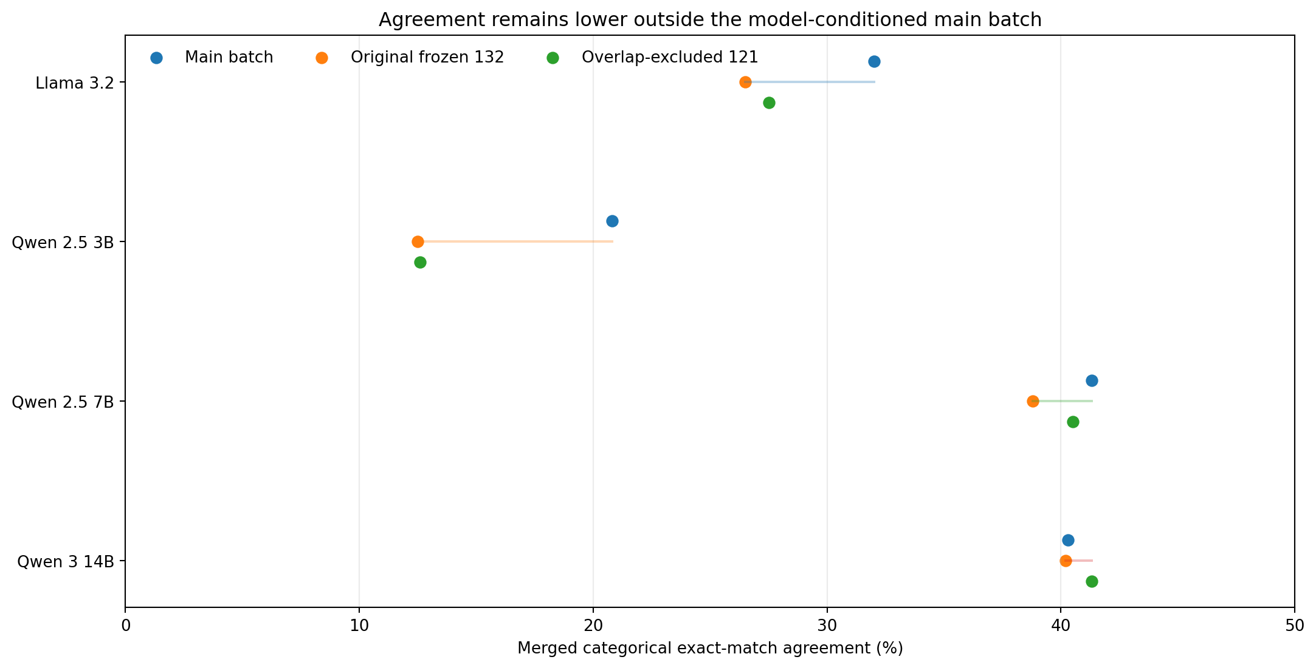
Figure 5. Merged categorical exact-match agreement on the model-conditioned main batch, original frozen 132-segment evaluation set, and post-audit overlap-excluded 121-segment analysis. The original 132 and the post-audit 121 are shown together to make the identifier-overlap correction visible without treating the 121 as an unqualified independent unseen-episode sample.
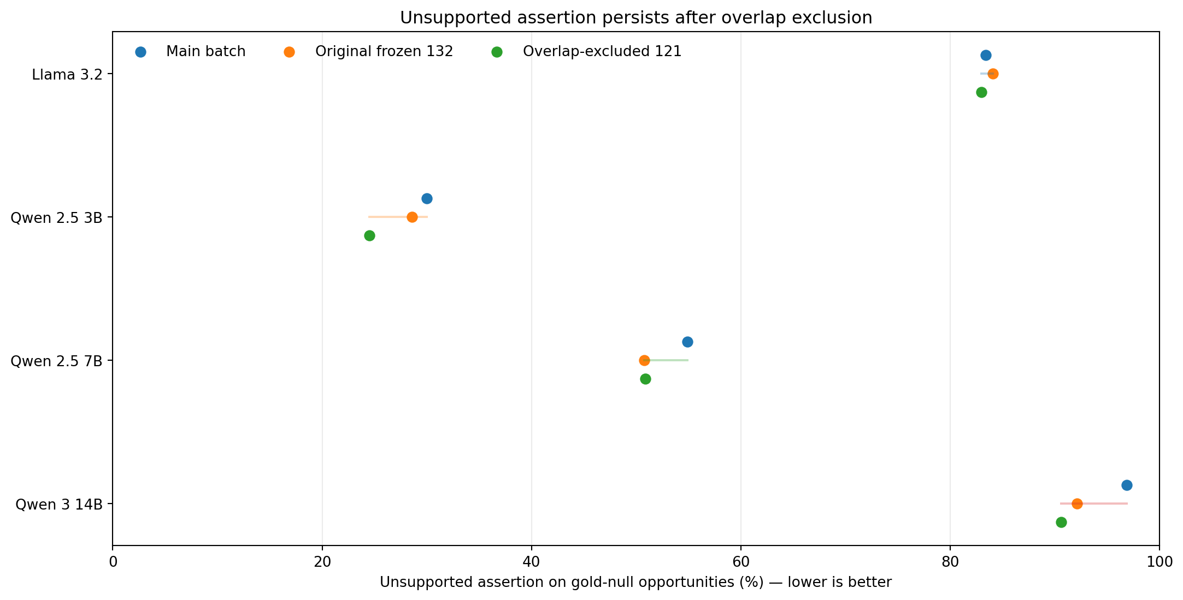
Figure 6. Unsupported assertion on gold-null opportunities in the model-conditioned main batch, original frozen 132-segment evaluation set, and overlap-excluded 121-segment analysis. Lower is better. The correction for 11 overlapping episodes did not change the qualitative ordering.

3.4. Main-batch generator behavior
On the 330-segment main batch rescored against the post-compliance-audit reference, Qwen 2.5 7B had the highest merged mean categorical agreement (41.3%; 95% child-cluster CI 34.9%-47.3%), followed by Qwen 3 14B (40.3%; 31.9%-48.5%), Llama 3.2 (32.0%; 25.2%-38.3%), and Qwen 2.5 3B (20.8%; 17.9%-23.7%). Whole-record exact-match agreement across all four categorical fields was 2.1% for Qwen 2.5 7B, 0.9% for Qwen 3 14B, 0.6% for Llama 3.2, and 0.9% for Qwen 2.5 3B; the corresponding child-cluster intervals were wide and these whole-record values are treated descriptively. The low whole-record values illustrate how errors compound when a structured record contains several fields. For Qwen 2.5 7B, field-level main-batch agreement was 42.4% for domain, 70.6% for modality, 18.8% for prompt_level, and 33.3% for outcome.
Table 7. Main-batch extraction performance against the post-compliance-audit final-codebook reference standard (n = 330). Missed-value rate is the share of all scored field slots in which the reference records a value and the model returns null or omits the field; it is reported separately from unsupported assertion. The pooled unsupported-assertion rate is opportunity-weighted across reference-null field slots; field-level numerators and denominators are reported in the text and Supplementary Material 6.
Generator | Merged agreement | Whole-record agreement | Missed-value rate | Unsupported assertion
Llama 3.2 | 32.0% [25.2-38.3] | 0.6% [0.0-1.8] | 8.3% | 161/193 (83.4%) [79.6-86.6]
Qwen 2.5 3B | 20.8% [17.9-23.7] | 0.9% [0.0-1.8] | 48.2% | 58/193 (30.0%) [24.3-34.6]
Qwen 2.5 7B | 41.3% [34.9-47.3] | 2.1% [0.6-3.6] | 12.6% | 106/193 (54.9%) [43.0-74.4]
Qwen 3 14B | 40.3% [31.9-48.5] | 0.9% [0.0-2.4] | 2.9% | 187/193 (96.9%) [93.3-99.3]
Unsupported assertion exposed a different dimension of model behavior from merged agreement. Across 193 post-audit main-batch reference-null field opportunities, Llama 3.2 asserted a value in 161 (83.4%; 95% child-cluster CI 79.6%-86.6%), Qwen 2.5 3B in 58 (30.0%; 24.3%-34.6%), Qwen 2.5 7B in 106 (54.9%; 43.0%-74.4%), and Qwen 3 14B in 187 (96.9%; 93.3%-99.3%). The corresponding null rates on answerable fields were 9.7%, 56.4%, 14.7%, and 3.5%, while overall model-null rates across all scored slots remained 10.7%, 58.4%, 19.2%, and 3.4%. The largest model was therefore not the most conservative on unsupported fields. In the unchanged post-audit overlap-excluded 121-set, Qwen 3 14B had slightly higher merged agreement than Qwen 2.5 7B (41.3% vs 40.5%) but a substantially higher unsupported-assertion rate (90.6% vs 50.9%); under the primary episode-weighted estimand, the paired unsupported-assertion difference was +39.6 percentage points (95% CI +14.8 to +53.7), whereas the +0.8-point merged-agreement difference had a 95% CI crossing zero (-2.6 to +3.9). Under equal-child weighting, the unsupported-assertion difference was +20.6 points (95% CI -7.6 to +45.9), so the magnitude and uncertainty of that contrast were sensitive to child weighting. Across this four-model roster, lower overall model-null rate coincided descriptively with higher unsupported assertion. With only four models, this is a roster-specific pattern rather than a general relationship.
Reference-null opportunities were strongly imbalanced by field. In the post-audit 330 main batch, the 193 opportunities comprised domain 3, modality 80, prompt_level 4, and outcome 106. Field-level unsupported-assertion counts for Llama 3.2 were 3/3, 75/80, 4/4, and 79/106; for Qwen 2.5 3B, 0/3, 17/80, 0/4, and 41/106; for Qwen 2.5 7B, 2/3, 32/80, 2/4, and 70/106; and for Qwen 3 14B, 3/3, 79/80, 3/4, and 102/106, respectively. In the post-audit 121-set, domain and prompt_level had no reference-null opportunities; the 53 opportunities comprised modality 30 and outcome 23. The corresponding modality/outcome unsupported counts were 26/30 and 18/23 for Llama 3.2, 5/30 and 8/23 for Qwen 2.5 3B, 13/30 and 14/23 for Qwen 2.5 7B, and 28/30 and 20/23 for Qwen 3 14B. The pooled unsupported-assertion rate is therefore opportunity-weighted and, particularly on the 121-set, is driven by modality and outcome rather than representing an equal four-field safety score; field percentages with very small denominators are descriptive only. Full field-level tables are assigned to Supplementary Material 6.
Free-text behavior similarity was lower for models than for the two human annotators. Median Jaccard word-set overlap was 0.316 between annotators, compared with 0.083 for Qwen 2.5 7B against gold and 0.071 for both Llama 3.2 and Qwen 2.5 3B. Because human descriptions of the same event frequently used different wording, this lexical metric is interpreted as a lower-bound similarity indicator rather than semantic correctness.
Qwen 2.5 7B is the extractor designated for the final frozen research prototype request path under the original pre-specified agreement rule. That rule was written before any reference labels existed and selected the generator with the highest agreement on the adjudicated main batch. When the 330-segment batch was first scored on 15 September 2026, Qwen 2.5 7B ranked first under both whole-record and merged mean categorical agreement; Qwen 3 14B was added to the scored roster afterward. After the final-codebook compliance audit, rescoring the preserved outputs still left Qwen 2.5 7B first on merged agreement (41.3% versus 40.3% for Qwen 3 14B). The frozen evaluation sample was created only after the original Qwen 2.5 7B selection and was used for subsequent assessment, not to make or revise that selection. The preserved generator outputs for all four models used the original prompt/schema condition rather than a final-codebook-aware prompt. The final frozen research build intentionally retains prompt version 1.0.0 to match the evaluated condition; any later prompt that incorporates the finalized codebook definitions will be treated as a new extraction condition requiring separate evaluation. A subsequent repository audit found that the current default configuration was still Llama 3.2, so alignment to the designated Qwen 2.5 7B build remains to be verified before submission. Because generator inference used server defaults without a generation seed, this is a single-run preserved-output comparison, not evidence that the ranking is stable across repeated generations. Every extracted record nevertheless requires professional verification before analytics eligibility regardless of generator choice.
Evaluation results did not uniformly favor Qwen 2.5 7B on every metric. On the overlap-excluded 121-set, Qwen 3 14B had 0.8 percentage points higher merged agreement (41.3% vs 40.5%; paired 95% CI -2.6 to +3.9), while Qwen 2.5 7B had higher whole-record agreement descriptively (5.0% vs 4.1%) and substantially fewer unsupported assertions (27/53 vs 48/53; 50.9% vs 90.6%). The original frozen 132-set showed the same qualitative ordering. Unsupported-assertion rate was not part of the original model-selection rule; the prototype choice is therefore reported as an agreement-based selection that was subsequently assessed on evaluation data, rather than as a model selected for overall safety or global superiority.

3.5. Offline MARS reranking
Across the 330 main-batch segments, MARS returned a record for 265 (80.3% coverage), abstained because there was no reviewable candidate for 42 (12.7%), abstained because judges disagreed for 21 (6.4%), and had insufficient valid judge responses for 2 (0.6%). The candidate stage short-circuited on 123 segments with only one reviewable candidate and triggered reranking on 165. Of those 165, 142 produced a genuine usable ranking decision and 23 ended in judge-related abstention.
At full-policy whole-record level after rescoring against the post-compliance-audit reference, MARS achieved 1.5% agreement across all 330 when abstentions were counted as failures and 1.9% among the 265 records it returned. Qwen 2.5 7B achieved 2.1% whole-record agreement on all 330. Full-policy coverage and whole-record agreement are therefore reported together; these numbers describe what the complete selector policy returns, whereas the 142-segment analysis below isolates how well MARS selected when genuine reranking was possible.
On those 142 segments, MARS achieved 41.9% mean field agreement, compared with 44.0% for the strongest-generator fallback policy and 37.0% for the analytical expected random choice among distinct reviewable candidates. The field-level child-cluster paired bootstrap comparisons are unadjusted for multiplicity and are treated as exploratory rather than confirmatory. Against the random reviewable-candidate comparator, MARS-minus-random differences were +4.9 percentage points for domain (95% CI +0.2 to +9.7), +10.0 for modality (+5.0 to +15.9), -0.7 for prompt_level (-4.8 to +3.6), and +5.4 for outcome (+1.3 to +8.4). Against the strongest-reviewable-generator policy, the corresponding differences were -12.7 points for domain (-17.9 to -6.9), -2.8 for modality (-8.8 to +3.5), +2.1 for prompt_level (-4.5 to +7.8), and +4.9 for outcome (+0.0 to +9.4). Thus the unadjusted exploratory intervals exclude zero for domain, modality, and outcome versus random and for the lower domain result versus the strongest-generator comparator; no familywise confirmatory inference is made. Because the strongest-generator comparator was selected from the same main-batch reference labels, its 44.0% mean field agreement is an in-sample benchmark and may be optimistic relative to an independently selected policy. The post-audit original-three-generator whole-record oracle ceiling was 12/330 (3.6%), further limiting the headroom available to a selector when candidate quality was weak. The evaluated selector therefore did not establish a consistent advantage over the strongest-generator policy.
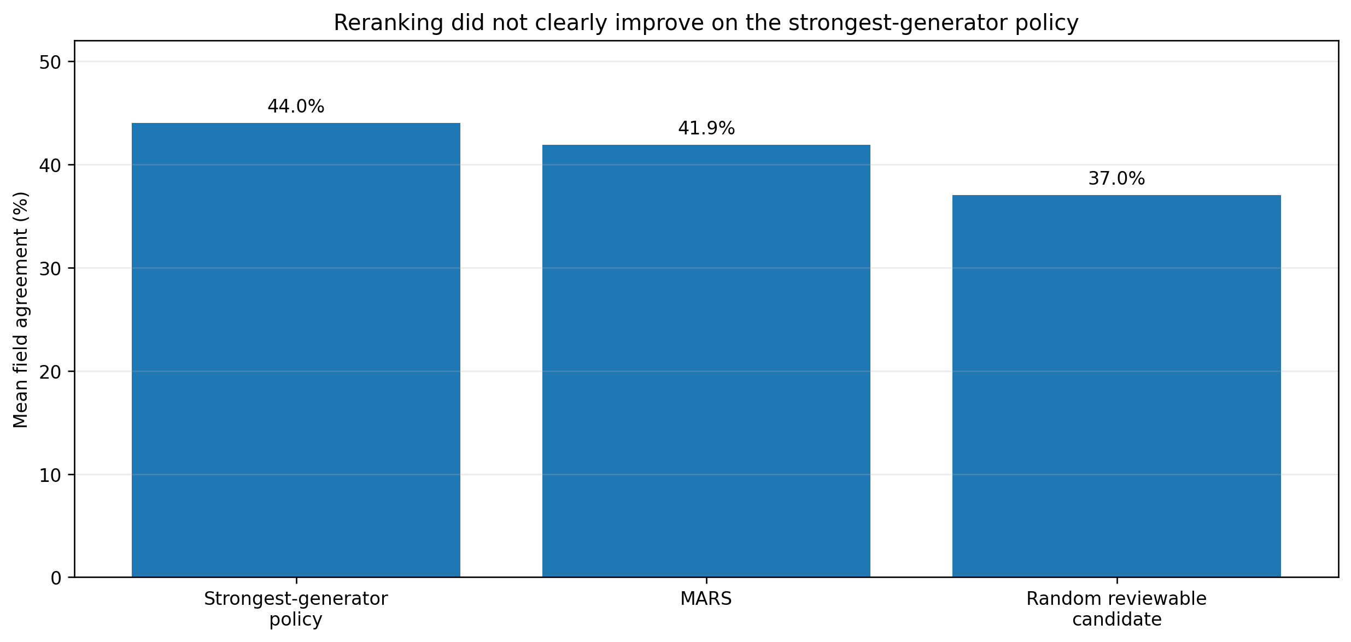
Figure 7. Mean field agreement on the 142 genuinely reranked segments using the primary comparator definitions. The random baseline is the analytical expectation over distinct reviewable candidates, and the strongest-generator comparator applies the prespecified fallback policy when Qwen 2.5 7B is not reviewable.

3.6. Adequacy routing and reporting governance
For the 11 child-level reporting packets, the adequacy router classified every case as limited, driven by the two failed representation checks: each child's packet contained one setting and one contributor role derived from corpus structure. The packet structured records used adjudicated human reference values for behavior, domain, modality, prompt_level, and outcome; corpus-derived or synthetic administrative metadata supplied child/session identity, setting, contributor role, observation date, record identifier, and version. duration_seconds, goal_context, and prompt_context were absent, and no structured-record value came from model extraction output. No packet contained an active goal, so goal coverage passed deterministically without a goal-to-record mapping; coverage, temporal distribution, goal coverage, and field completeness passed in all 11, whereas contributor-role and setting representation failed in all 11. Fourteen KPI families were defined. Twelve were computed for every child; the cross-setting and cross-contributor comparison families were withheld for all 11, and the withholding objects and reasons remained in the complete model-visible EvidencePacket. No adequate or insufficient packet was included in this corpus-derived reporting experiment, so the results characterize this limited-state, no-active-goal configuration rather than all possible governance states.
Table 8. Governance evaluation of the experimental generative reporting layer across 11 child-level reports.
Generative-report governance check | Result | Interpretation
Structurally conformant | 11/11 | Every report parsed into the required schema
No prohibited diagnostic/treatment/causal/prognostic content | 11/11 | No overt prohibited clinical claims
All numeric assertions traceable to packet values | 3/11 | 8 of 122 numeric assertions (6.6%) were absent from the evidence packet
Evidence-reference IDs resolved | 834/836 (99.76%) | 2 references did not resolve
Withholding-acknowledgement contract satisfied | 0/11 | 0/11 under the historical lexical validator; semantic omission cannot be determined from preserved artifacts
Passed deterministic governance validation | 0/11 | 0/11 passed the tested prompt/schema/context/validator contract

The numeric and evidence-reference checks were traceability checks rather than tests of full semantic grounding. A numeric assertion passed when the same value appeared somewhere in the supplied EvidencePacket at the reported precision, and an evidence reference passed when its identifier resolved to an allowed record; these checks did not establish that the number belonged to the correct KPI/field or that the referenced record semantically entailed the associated narrative statement. None of the 11 reports satisfied the tested withholding-acknowledgement contract under the pre-specified lexical validator. That result should not be interpreted as a clean semantic omission rate: the prompt asked for a JSON array while the constrained schema required a top-level object containing sections; abstention_note was described in the prompt but optional in the schema; the prompt explicitly referenced 'limited' evidence while the acknowledgement rule accepted the KPI name, 'withheld', or 'insufficient' but not 'limited' alone; and the rule ignored headings and abstention_note. The raw generated report prose was not preserved, so semantically equivalent language that the lexical rule may have missed cannot be assessed and the 0/11 result cannot be independently recomputed from primary generated outputs. The complete reconstructed inputs contained all withholding objects and fit within 8,192 tokens, but only 183-776 tokens of nominal context headroom remained for output and actual output lengths were not saved, so output-window effects cannot be excluded. No post-result prompt remediation was performed. Generative reporting was marked experimental and the deterministic reporter became the operational default.
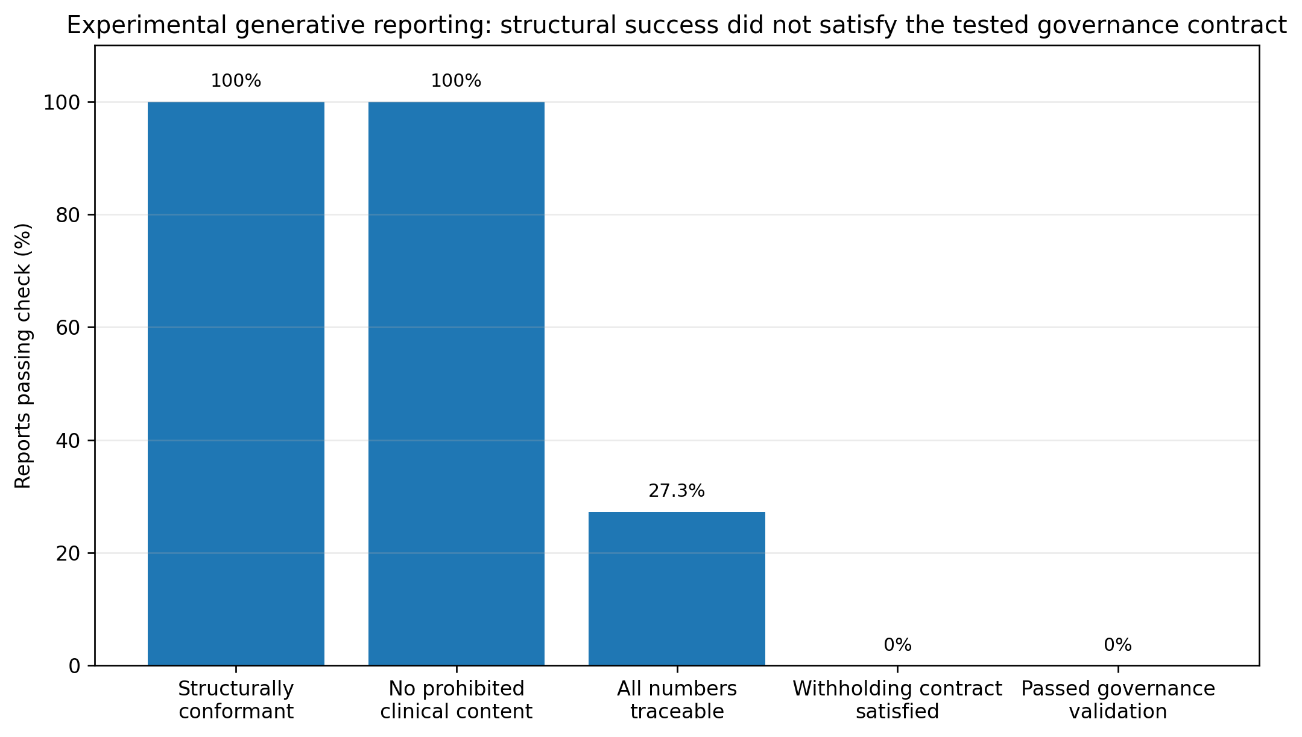
Figure 8. Governance evaluation of the experimental generative reporting layer (n=11 reports). Structural conformance and avoidance of prohibited clinical content did not ensure satisfaction of the tested withholding-acknowledgement, numeric-traceability, and evidence-reference validation contract; raw generated report text was not preserved for retrospective semantic review.

4. Discussion

4.1. Principal findings
The central finding of this study is not that one language model can reliably read autism intervention evidence. The results argue almost the opposite. A longitudinal support system becomes more governable when it assumes that each layer can fail in a different way and gives that failure somewhere explicit to go. Human definitions can be underspecified. Extractors can populate unsupported fields. An apparently stronger or larger model can answer more often while also asserting unsupported fields more frequently. A reranker cannot recover a correct candidate that was never generated. A reporting model can obey a constrained schema yet still fail the tested withholding-acknowledgement contract. The final architecture therefore treats trustworthiness as a property of the whole evidence pathway rather than a characteristic assigned to one model.
The application-level contribution is therefore the governed linkage of these failure states across a longitudinal workflow. An unsupported field is not the same as an unverified structured record; an unverified record is not the same as inadequate longitudinal representation; and an inadequate analysis is not the same as a report that omits the fact that the analysis was withheld. Keeping those states distinct—and traceable back to source evidence—allows different safeguards to act at the layer where each failure occurs.
That system-level view changed the application itself. Final architecture review and implementation audit identified an important defect: schema-valid AI records could previously enter analytics without semantic verification. The corrected design now requires an intervention specialist to verify or correct every AI-derived structured record before longitudinal metrics can use it. Likewise, the reporting experiment did not lead to a better prompt being quietly substituted after the fact. Its failure changed the prototype boundary: deterministic reporting became the default, while generative reporting remains experimental.

4.2. Returning to the intervention specialist: what problem is the system actually trying to solve?
It is easy for a technically dense paper to lose sight of the person who motivated the system. The intervention specialist does not begin the day with a need to compare LLMs. The specialist begins with scattered evidence. One observation may be detailed, another may be late, another may omit the prompt that was used, and another may come from a setting that has not been represented for weeks. The professional still has to answer a practical question: what does the accumulated evidence support, and what is still missing before a responsible interpretation can be made?
The application is designed to reduce the organizational burden around that question without transferring the question itself to AI. Contributors can continue to communicate in ordinary language. The system can remind the team when expected evidence has not arrived, preserve the original wording, propose structure, surface missing fields, and compute reproducible descriptive indicators after professional verification. The specialist remains the person who decides whether the evidence is meaningful in the context of the child, the goal, and the intervention plan. This division of labor is deliberate: AI is used to make the evidence easier to organize, not to make the intervention decision.
That distinction also makes representation limits visible. Parent-teacher differences are well documented in autism [1,2], but the current prototype does not yet model goal-specific exemptions for single-setting goals. Its adequacy router applies global representation checks across the child's accepted records in the review period: fewer than two settings or contributor roles prevents an ADEQUATE state and withholds the matching cross-comparison. This is intentionally conservative and should not be confused with a clinical judgment that every goal requires every setting; goal-specific applicability is a future refinement.

4.3. Define the evidence before judging the model
The annotation study showed that model evaluation can become unstable before the model is ever involved. Round-1 modality agreement was modest, but the maximum attainable kappa under the annotators' marginal usage was itself restricted. Most disagreements concentrated around three identifiable boundaries rather than diffuse professional disagreement. On the 178 disagreement-enriched segments that were re-issued, agreement rose substantially for the three clarified fields while the unchanged domain comparator did not improve. The mixed paired pre-audit mean kappa of 0.801 across all 330 is not a clean before-versus-after codebook estimate because the 152 unreissued segments retained earlier labels for that reliability calculation. The later model-blind joint compliance audit showed why agreement alone was not sufficient evidence of final-codebook consistency: 98 of 456 targeted labels in the 152 unreissued segments required correction, including 97 labels that both annotators had originally agreed upon. Those corrections define the final post-compliance-audit reference used for main-batch scoring, while the 0.801 value remains a mixed paired pre-audit reliability descriptor rather than an audit outcome or a reliability estimate of the corrected gold standard. The separate mean kappa of 0.910 from the first pass within the frozen evaluation annotation round, and 0.926 after excluding the 11 exact episode overlaps, continue to describe application of the final coding protocol on the separate evaluation material.
This matters because an LLM benchmark inherits the weaknesses of its reference standard. If two qualified readers do not share the same definition of a communicative gesture, a model can be penalized or rewarded against an unstable target. Explicit null annotation is similarly important. A field being absent from the evidence is not a nuisance to be filled in; in this study it is an observable reference-standard state. That makes unsupported inference countable rather than anecdotal.

4.4. Model willingness to answer is not evidence quality
The generator results reinforce that point. Qwen 3 14B was competitive on merged categorical agreement and slightly exceeded Qwen 2.5 7B on the unchanged post-audit overlap-excluded 121-set (41.3% vs 40.5%), yet its overall model-null rate on the rescored main batch was only 3.4% and it asserted values on 96.9% of post-audit main-batch and 90.6% of post-audit evaluation gold-null opportunities. The paired 121-set difference in merged agreement was small and uncertain (+0.8 points; 95% CI -2.6 to +3.9). Under the primary episode-weighted estimand, the unsupported-assertion difference was +39.6 points (95% CI +14.8 to +53.7); under equal-child weighting it was +20.6 points (95% CI -7.6 to +45.9), showing that this contrast was sensitive to sparse and uneven child-level reference-null opportunities. A model that rarely leaves a field null can look operationally convenient while quietly removing the distinction between observed evidence and inference. In a longitudinal database, that failure is particularly consequential because one unsupported field can be aggregated repeatedly across time.
A further qualification is that the preserved generator outputs were produced under extraction prompt version 1.0.0, which predated the specialist clarifications that stabilized three human coding boundaries. Qwen 3 14B used the same prompt/schema condition even though it was run after the codebook had been written. The reported exact-match estimates therefore characterize an original operational prompt/schema condition scored against a subsequently stabilized human reference standard; they do not estimate performance of an extractor explicitly instructed with the final codebook rules. The final frozen research build therefore retains this historical evaluated prompt condition and relies on mandatory professional verification rather than claiming that the extractor implements the final human codebook. A future prompt that explicitly incorporates the finalized definitions would be a new extraction condition and should be evaluated separately.
The evaluation-set results also make the main-batch limitation concrete. Every model's merged agreement was lower on both the original frozen 132 and the post-audit overlap-excluded 121 than on the model-conditioned main batch. Stable-identity audit showed that the original identifier-based exclusion swapped 136 pool and 136 non-pool episodes in the sampling frame, and 11 frozen evaluation records represented pool episodes. Removing those 11 without redrawing the sample changed point estimates only modestly, but the 121 remains a post-audit analysis from the originally frozen frame rather than an unqualified independent unseen-episode sample. The same-universe sensitivity analysis likewise did not isolate a single explanation for the between-branch difference: neither model-tractability conditioning nor the change in candidate universe accounted for the pattern on its own across the four generators, and annotation-stage differences remain. The appropriate interpretation is therefore descriptive and sensitivity-based rather than causal. A source-turn audit further showed that five of the 121 retained evaluation episodes each shared only one boundary utterance with a main-batch episode. Excluding those five without replacement left 116 episodes and shifted no central generator metric by more than 1.0 percentage point, so the broader comparative interpretation was unchanged.

4.5. Why reranking did not rescue weak candidates
MARS produced a useful but bounded result. After post-audit rescoring, MARS achieved 41.9% mean field agreement on the 142 genuinely reranked segments, compared with 37.0% for the analytical expected random reviewable candidate and 44.0% for the in-sample strongest-generator fallback policy. The eight field-specific child-cluster intervals (four versus random and four versus strongest) were not multiplicity-adjusted and are interpreted as exploratory. Under that framing, MARS showed positive exploratory differences versus random on domain, modality, and outcome, while prompt_level was uncertain; against the strongest-generator policy, domain was lower and the other field intervals included zero. Across the full 330-segment policy, MARS returned a record for 80.3% of segments and achieved 1.5% whole-record agreement when abstentions were counted as failures (1.9% among returned records), compared with 2.1% for Qwen 2.5 7B. The post-audit three-generator oracle ceiling was only 3.6%. Candidate selection can reorder available answers; it cannot manufacture a correct record when no generator proposed one.
For that reason, MARS remains an offline evaluation tool rather than part of the prototype request path. The reported judges were deliberately codebook-naive, so this is not a claim that multi-model selection is generally unhelpful or that a codebook-aware judge condition would behave the same way. A stronger or more balanced candidate roster, or judges given the task-specific codebook, could create a different result. The present evidence simply does not justify live multi-model complexity for the evaluated roster and condition.

4.6. Schema-constrained generation is not governance-constrained generation
The reporting experiment exposed a different failure mode, but the scope of that finding is configuration-specific. Native schema-constrained decoding produced structurally conformant outputs in all 11 cases and the model avoided prohibited diagnostic, treatment, causal, and prognostic language. However, none of the 11 reports satisfied the tested withholding-acknowledgement contract. The historical configuration itself contained mismatches: the prompt requested a JSON array while the constrained schema required a top-level object containing sections; abstention_note was described by the prompt but optional in the schema; and the prompt's 'insufficient or limited' language was not fully mirrored by a lexical validator that accepted the KPI name, 'withheld', or 'insufficient' in section body text but did not inspect abstention_note. Eight numeric assertions also had no matching value anywhere in the supplied EvidencePacket. These findings therefore characterize failure of the tested prompt/schema/context/validator contract, not a clean semantic estimate of whether every narrative omitted every withholding state.
The negative result remains informative because the pre-existing deterministic checks exposed a mismatch between the reporting configuration and the system's desired governance contract that structural JSON conformance alone did not reveal. The complete EvidencePackets, including both withholding objects, fit in the reconstructed 8,192-token inputs, but the largest input left only 183 tokens of nominal context headroom and actual report lengths were not preserved; output-window effects therefore cannot be ruled out. More importantly for reproducibility, the retained reporting artifact stores validation/scoring outcomes and error messages rather than the generated report prose, so the original 0/11 result cannot be independently recomputed from primary model outputs and semantically equivalent wording that the lexical validator may have missed cannot be retrospectively assessed. Rather than quietly tuning the prompt after seeing the result, the generative reporter was removed from the default operational path. The broader design lesson is therefore narrower: when withholding is safety-relevant, its representation should be explicit and mandatory in the output contract and validation should test that representation directly rather than infer it from loosely constrained prose.

4.7. Relationship to prior work
Recent health-AI research increasingly combines LLM capability with task-specific reference standards, expert evaluation, and workflow constraints rather than relying only on general benchmarks. Edwards et al. used human-in-the-loop review for clinical free-text identification [6]; Eryilmaz et al. evaluated structured extraction from clinical text using a deliberately specified reference framework [7]; Carenzo et al. evaluated discharge-summary generation within a secure clinical environment and emphasized the need for larger validation [8]; and CLEVER formalized blinded expert comparison of LLM outputs [10]. Our findings are aligned with that direction but focus on a longitudinal evidence store in which unsupported structured fields can propagate into later calculations.
The work is also related to AI-supported autism and behavioral-health workflows. ASIST showed that a bounded conversational system can support structured autism history taking while retaining a referral-support role [5]. shamiriAI demonstrated the value of decomposing an AI-enabled behavioral-health workflow into separately evaluated stages [9]. Our target is different: goals already exist, observations accumulate over time from multiple contributors, and the primary problem is evidence preparation for professional review rather than screening, referral, or autonomous recommendation.
The application-level distinction in this work is the longitudinal connection among multi-informant evidence capture, immutable source preservation, professional verification of AI-derived structure, explicit adequacy and representation states, deterministic analytics, and evidence-linked reporting. None of those elements is presented as novel in isolation. The contribution is the governed composition: each downstream result can be traced to professionally accepted evidence, and the system preserves absence or withholding as an explicit state rather than asking a language model to smooth over it. Additional autism-intervention and multi-informant digital-workflow literature will be incorporated during the final citation pass.
Selective prediction and abstention research provides another important foundation [11,12]. This study extends the abstention idea across a pipeline. Null can exist at extraction; analytics can abstain when representation is inadequate; and reports must preserve those upstream states. Trustworthy-AI guidance such as FUTURE-AI, DECIDE-AI, and iCHECK-DH similarly emphasizes traceability, human oversight, staged evaluation, and transparent reporting [14-16]. The present study does not establish compliance with those frameworks or clinical trustworthiness; it operationalizes several of their principles in a system whose failure modes are deliberately measurable.

4.8. Human authority and appropriate reliance
Human-in-the-loop design is not achieved merely by placing a professional after the model. Oversight becomes meaningful only when the professional can inspect the original evidence, understand what the model proposed, correct the structured record that drives future calculations, and see why downstream analyses were withheld. Editing a polished report while leaving a wrong structured record untouched would allow the same error to recur. The versioned evidence model therefore treats correction at the evidence layer as the authoritative intervention.
The mandatory verification gate also creates a new empirical question. If most records require correction, the gate may impose substantial review burden; if professionals tend to confirm suggestions without re-reading the source, automation bias could recreate the very risk the gate was designed to prevent. Neither burden nor automation bias was measured here. A future evaluation should therefore examine not only whether intervention specialists can use the application, but whether the interface supports appropriate reliance: noticing unsupported extraction, recognizing insufficient representation, using source traceability, and correcting evidence before it propagates.

4.9. Limitations
Several limitations constrain interpretation. First, the 330-segment main batch was conditioned on generator judgeability. The three codebook clarifications were discovered through disagreement analysis within that model-conditioned batch, so the initial boundary discovery itself arose from a model-tractable subset; the separately sampled evaluation set subsequently tested application of the finalized rules but cannot establish that other input distributions would not expose additional boundaries. The separately frozen 132-segment evaluation sample did not use generator output for inclusion, but it came from a higher-cap universe and its original identifier-based pool exclusion was later found to be imperfect. Stable-identity audit showed that 136 true pool episodes were wrongly retained and 136 true non-pool episodes were wrongly excluded from the intended 2,051-record frame, with uneven child-level distortion; 11 of the frozen 132 were pool episodes. We therefore report the original 132 transparently and a post-audit 121 after excluding the 11 exact episode overlaps, without redrawing the sample. Because adjacent episodes can share a boundary utterance, this 121-set is exact-episode-overlap-excluded rather than fully source-turn-disjoint. A source-turn audit found five retained evaluation episodes that each shared one boundary turn with one main-batch episode; excluding those five without replacement left 116 episodes and changed no central metric by more than 1.0 percentage point. Re-weighting on observed episode type also changed estimates only minimally, but 160/2,051 intended-frame episodes (7.80%) belonged to child-specific episode types absent from the sampled 121-set and were left unaccounted rather than imputed; unobserved frame differences therefore remain possible. A same-universe sensitivity analysis also did not justify attributing the lower evaluation-branch agreement to model-tractability conditioning or the higher-cap universe alone. The primary 121-set estimand is episode-weighted; equal-child sensitivity estimates were similar for merged and whole-record agreement, but the unsupported-assertion contrast between Qwen 3 14B and Qwen 2.5 7B was more sensitive because reference-null opportunities were sparse and uneven across children. The 121 still contains the same 11 children and two corpora and does not provide external validation across populations or interaction types.
The deterministic universe-construction procedure adds a temporal representativeness limitation. Because episodes were retained in transcript order within child-by-episode-type strata, both constructed universes overrepresented earlier sessions, particularly the 2,442-segment universe (mean relative session position 0.284 versus 0.503 across all segmented episodes; 70 of 85 sessions represented). The 3,371-segment universe extended farther longitudinally (mean 0.337; 84 of 85 sessions), and the main and post-audit evaluation branches likewise differed in longitudinal reach (0.273 versus 0.385). Reported extraction estimates therefore characterize earlier portions of the source records more heavily than later portions. Exploratory stratification of the existing scored outputs did not reveal a consistent early-versus-later performance pattern across generators, but sparse reference-null opportunities in the later evaluation subset and the post-hoc nature of this diagnostic mean that temporal invariance cannot be assumed.
The episode representation adds a related task-definition limitation. The eight-turn maximum was fixed before segmentation but was not empirically optimized, and 52.2% of constructed episodes reached it. Model-free re-segmentation showed that larger caps reduce cap-hitting and alter episode counts; the eight-turn rule primarily splits long exchanges into subsequent episodes, preserving most transcript coverage while losing context across the split. The descriptive comparison reported in Results showed lower mean reference-null frequency in capped than shorter episodes in both annotated sets. Because those groups may differ in ways other than window length, the comparison does not isolate an effect of the cap; extraction behavior and the opportunities for unsupported assertion may therefore differ under longer context windows. A full re-annotation under alternative caps was not performed because that would define a different reference task.
Second, ASDBank transcripts are not the same input distribution as contributor-authored longitudinal intervention notes. The study therefore cannot estimate how extraction performance transfers to real parent, teacher, caregiver, trainer, or practitioner observations. Notes may be more concise and goal-oriented than transcripts, which could help extraction, or they may omit details that are present in dialogue, which could hurt it. The direction is unknown.
The computational sample is also small at the child level. All child-cluster bootstrap intervals are based on only 11 child clusters and should therefore be read as descriptive uncertainty summaries rather than well-calibrated confirmatory inference; whether an exploratory interval excludes zero can be unstable with so few clusters. Kappa-bootstrap invalidity was rare (at most 3 of 10,000 replicates in the affected modality intervals) and arose only when a resample collapsed to a single category, but the small-cluster limitation remains. The main text summarizes the interaction sources, child count, session count, and utterance count used directly in the analysis, but participant-level age and developmental/language characteristics have not yet been added to the manuscript. Those characteristics should be verified against repository metadata and access terms and reported in Supplementary Material 5 before submission; no subgroup or fairness inference is made from the current 11-child sample.
Third, the reference standard was developed by two autism intervention specialists. The same pair helped identify underspecified definitions and later applied the clarified codebook, and no independent third adjudicator was used. The 0.801 mean kappa remains a mixed paired pre-audit reliability descriptor combining Round-2 labels for the 178 disagreement-enriched segments with retained Round-1 labels for the other 152; it should not be interpreted as a causal codebook effect or as proof that the unreissued labels already complied with the final rules. A later model-blind joint compliance audit of the 152 unreissued segments checked all 456 targeted modality/outcome/prompt_level labels and changed 98 labels across 85 segments; 97 of those changed labels had originally been agreed by both annotators. Because the two returned audit worksheets were identical, this audit is recorded as one joint specialist review rather than independent paired reassessment and does not support a new kappa estimate. The corrected labels define the post-compliance-audit main-batch reference used for final generator/MARS scoring. The evaluation-set reliability estimate comes from the first pass within that separate annotation round rather than guaranteed first exposure to every episode, and it still reflects accumulated annotator experience. Excluding the 11 exact episode overlaps increased the unweighted mean kappa only slightly, from 0.910 on the 132 to 0.926 on the 121. The frozen-set adjudication also adopted one specialist's returned value more often than the other's (79 vs 54 decisions); because most differences were free-text behavior wording rather than substantive categorical judgments, this asymmetry is reported descriptively rather than treated as evidence of systematic superiority.
Fourth, four categorical extracted fields were formally evaluated for exact agreement, while behavior received exploratory lexical Jaccard analysis rather than semantic expert validation. The application schema contains eight LLM-extracted fields in total. The three unevaluated fields are not used by prototype analytics or deterministic reporting. Although they remain part of the broader application schema, duration_seconds, goal_context, and prompt_context were absent from all EvidencePackets used in the experimental generative-reporting evaluation, and no structured-record value in those packets came from model extraction output. Accordingly, the reported extraction evidence should not be generalized to the full eight-field schema or to free-text behavior semantics.
Fifth, the generator roster comprised four locally served open-weight models and no frontier-scale external model. Generator inference used server defaults and no generation seed, so the model comparisons are single-run preserved-output comparisons rather than a repeat-generation stability analysis. Reproducibility is achieved by preserving and replaying the original outputs. The preserved generator outputs were produced under extraction prompt version 1.0.0, which did not contain the three specialist clarifications later formalized in the final human codebook; Qwen 3 14B used the same original prompt/schema condition. After the human final-codebook compliance audit corrected the main-batch reference, the same preserved outputs were rescored without regeneration; Qwen 2.5 7B remained first on merged agreement, but several absolute metrics and the whole-record oracle ceiling changed. The reported exact-match results therefore evaluate the original prompt/schema condition against the final post-compliance-audit human reference and should not be interpreted as performance of a final-codebook-aware extractor. The final frozen research prototype intentionally retains prompt version 1.0.0 so that the deployed study condition matches the evaluated condition; any later prompt that incorporates the finalized definitions would be a new extraction condition requiring separate evaluation. MARS used only the original three-generator candidate roster, its judges were codebook-naive, and some judges shared model families. The strongest-generator comparator was in-sample and data-selected from the same main-batch reference labels that contain the 142 reranked cases, and the eight field-level MARS comparisons are unadjusted for multiplicity and exploratory. A different roster, final-codebook-aware extraction prompt, judge prompt, codebook-aware selector condition, independently selected comparator, or multiplicity-adjusted confirmatory analysis could change the observed relationship.
Sixth, the adequacy rules are prototype governance thresholds. They make system behavior inspectable but are not clinically validated, were not derived from expert consensus, and have not undergone sensitivity analysis. The current representation checks are global across the child's accepted records rather than goal-specific, so a single-setting or single-contributor-role record set cannot be rated ADEQUATE even when a future real-world goal might reasonably be setting-specific. Three thresholds are currently implemented as code literals rather than externally configurable values.
Seventh, the generative reporting evaluation involved one model, one run, and 11 evidence packets assembled from the pre-compliance-audit adjudicated reference fields plus corpus-derived and synthetic administrative metadata; no model-derived structured field values were included. The experiment contained no active goals, used synthetic weekly review dates, and every packet was in the limited adequacy state because setting and contributor-role representation each failed; adequate, insufficient, full-abstention, active-goal, and other withholding configurations were not tested. The historical reporting contract was internally inconsistent: the prompt requested a JSON array while the schema required a top-level object containing sections; the prompt described abstention_note but the schema made it optional; and the prompt referenced 'limited' evidence while the lexical acknowledgement validator did not accept 'limited' alone and ignored abstention_note and headings. Generated report text and output-token counts were not preserved; only validation/scoring records and errors were retained, so the original 0/11 result cannot be independently recomputed from primary generated outputs or retrospectively assessed for semantically equivalent wording missed by the validator. Although every complete input packet fit within the configured 8,192-token context, only 183-776 tokens of nominal headroom remained for output and no output-token limit was set, so output-window effects cannot be excluded. The deterministic validator also checked packet-level numeric presence at the reported precision and evidence-identifier resolution rather than semantic entailment of each narrative statement. The 0/11 finding is therefore a failure of the tested prompt/schema/context/validator contract, not a clean semantic withholding-omission rate. The failure was not remediated or re-tested, and the later final-codebook compliance audit did not rerun this historical reporting experiment. The deterministic reporter preserves programmed withholding and evidence-display rules by construction; this does not establish language quality, usability, or clinical usefulness.
Finally, the application was built to address a practical burden that motivated the study: intervention specialists can spend substantial time reconstructing a longitudinal picture from fragmented observations written by different people in different settings. The implemented workflow is designed to reduce that organizational burden by organizing observations, surfacing missing evidence, preserving provenance, and presenting verified longitudinal indicators in one professional review surface. The present study, however, did not prospectively quantify time savings or determine how easily a broader group of practicing intervention professionals can incorporate the application into routine work. After aligning the repository configuration to the designated Qwen 2.5 7B extractor, the focused final end-to-end verification will record and verify the selected model name and digest/version, extraction prompt version/hash, and tool/output schema version/hash in addition to the governance-critical workflow invariants. The full automated test suite will be linked through the frozen study repository. Broader real-world evaluation is still needed to measure review time, correction burden, ease of adoption, workflow integration, and appropriate reliance. The system should therefore be considered a meaningful controlled-development research application and a foundation for testing practical benefit rather than production-ready software; no claim is made about treatment effectiveness, child outcomes, demographic fairness, or production-scale reliability.

4.10. Future work
The next phase should test whether the application delivers the practical benefit it was designed to pursue. We plan to seek collaboration with organizations that support autistic children and already manage longitudinal intervention observations. Practicing intervention professionals could use the application with controlled longitudinal cases or ethically approved de-identified observations, allowing direct measurement of review time, correction burden, evidence recognition, source-traceability use, missing-evidence detection, workflow fit, and ease of adoption. This would determine whether, and by how much, the system reduces organizational work while preserving careful professional review.
Organizational collaboration could also make representative contributor-authored intervention data available under appropriate legal, ethical, and data-use permissions. Such data would allow direct evaluation on the intended input distribution and could support a task-specific or domain-adapted extraction model. Depending on data volume, labeling quality, and permitted use, future work could compare supervised fine-tuning of a language model with a narrower non-generative structured predictor. In either case, deterministic schema validation, professional verification, adequacy routing, provenance, and deterministic longitudinal analytics should remain independent safeguards rather than being delegated to the learned model.
The adequacy router should also undergo expert review and sensitivity analysis before its thresholds are treated as more than prototype defaults. Future versions should support goal-specific applicability of setting and contributor-role representation instead of applying the same global representation requirement to every review. The episode-window maximum should likewise be exposed as a configurable parameter so that alternative context lengths can be specified prospectively and evaluated through sensitivity analysis for different datasets rather than treated as a universal constant. The three unevaluated extraction fields should receive their own reference standard or be removed from the extraction contract if they are not needed. A final-codebook-aware extraction condition should be evaluated separately from the original prompt/schema condition reported here. A remediated generative reporting configuration should make withheld-KPI representation explicit and mandatory in the output contract, use adequate output headroom, preserve raw generated text, and be tested across adequate, limited, insufficient, and varied withholding patterns while preserving the original 0/11 configuration-specific result. MARS would be worth revisiting only if a stronger or more balanced candidate roster creates meaningful oracle headroom; a codebook-aware judge condition should be evaluated separately from the codebook-naive condition reported here. Any later study of intervention decisions or child outcomes would require a separate protocol, ethics approval, and a substantially stronger evidence base. The present system is therefore a foundation for real-world professional validation, not the final endpoint.

5. Conclusions
Longitudinal autism intervention review is a human synthesis problem before it is an AI problem. The useful observations are distributed across people, settings, goals, and time, and the intervention specialist must decide what the accumulated evidence supports. This study developed a governance-aware application that tries to make that evidence easier to organize without moving professional authority into the model.
The component evaluations explain why the safeguards are necessary. Annotation definitions had to be stabilized before model evaluation was interpretable, and the 0.801 mixed paired pre-audit reliability descriptor could not be treated as a simple causal before-versus-after effect. A later joint final-codebook compliance audit of the 152 unreissued main-batch segments corrected 98 targeted labels across 85 segments, demonstrating that agreement under an earlier underspecified codebook was not sufficient to establish final-codebook compliance. Preserved model outputs were therefore rescored against the corrected post-compliance-audit main-batch reference. Merged agreement was lower in the separately sampled evaluation branch for most generators, but the audited frame differences and sensitivity analyses do not support attributing that difference to a single design factor. The post-audit overlap-excluded 121-set preserved the broader comparative pattern without redrawing the frozen sample, although the ordering of Qwen 2.5 7B and Qwen 3 14B on merged agreement was not stable across branches. Unsupported assertion remained substantial for several generators, while the magnitude and uncertainty of the Qwen 3 14B versus Qwen 2.5 7B difference on the 121-set were sensitive to child weighting. Models frequently asserted values where the human reference standard supported none, although these scores reflect the original prompt/schema condition rather than a final-codebook-aware extraction prompt. In the tested codebook-naive condition, the MARS selector policy returned a record for 80.3% of segments; the post-compliance-audit three-generator whole-record oracle ceiling was only 3.6%. On the 142 segments with a genuine usable reranking decision, unadjusted exploratory field-level comparisons did not establish a consistent advantage over the in-sample strongest-generator comparator. Under the tested limited-evidence reporting configuration, none of the 11 reports satisfied the full withholding-acknowledgement contract, but historical prompt/schema/validator mismatches and missing raw report text limit semantic interpretation and independent recomputation of that 0/11 result. Those findings changed or constrained the prototype architecture: AI-derived structured records require professional verification before analytics, and deterministic reporting is the default while generative reporting remains experimental.
The resulting system does not claim to diagnose, recommend treatment, improve child outcomes, or replace intervention specialists. Its practical aim is narrower and directly tied to a common workflow burden: preserve the original observation, make AI-derived structure reviewable, make missing evidence visible, compute only what verified evidence supports, and keep every longitudinal interpretation traceable to its source. That architecture provides a concrete foundation for testing whether the workflow can reduce the time and cognitive effort required to reconstruct a child's longitudinal story from fragmented notes. The next step is to measure that benefit with practicing intervention professionals and representative intervention data while preserving the same professional authority and governance boundaries.

Acknowledgments
The authors thank Som S. Mukherjee, PhD, Chief Operating Officer at Projee, Inc., and former PMO Director of the MD THINK Program at the Maryland Department of Human Services, for connecting the research team with the two autism-domain specialists and for facilitating their joint consensus-adjudication session. The specialists independently completed the annotation rounds before that session and requested that their identities remain undisclosed. The authors respect that request and acknowledge their substantial domain contribution without naming them.

Funding
[TO COMPLETE BEFORE SUBMISSION: Insert the final funding statement and disclose any material in-kind computing/model support. If no external funding was received, state that explicitly.]

Institutional Review Board Statement
[TO COMPLETE BEFORE SUBMISSION: Insert the exact final ethics/IRB determination, institution, protocol/reference number, date, and any conditions or exemptions. Do not submit with this placeholder.]

Informed Consent Statement
[TO COMPLETE BEFORE SUBMISSION: State the consent/waiver/not-applicable determination exactly as supported by the reviewing institution and the source-corpus terms.]

Data Availability Statement
The source transcripts are available to registered users from ASDBank (TalkBank) under the repository's access and licensing terms (Rollins corpus, doi:10.21415/T5KK53; Flusberg corpus, doi:10.21415/T5459F) and are not redistributed with this manuscript. Transcript-derived text, free-text labels that reproduce source language, adjudication rationales containing source text, and raw model-output files stored with transcripts will not be included in the public release. The public reproducibility package will instead provide code, schemas, prompts, codebook materials using synthetic examples, governance rules, evaluation scripts, categorical labels and per-segment verdicts under hashed identifiers, aggregate metrics, and a manifest containing SHA-256 hashes. Authorized ASDBank users will be able to regenerate the exact segment sets using the released scripts and verify them against the published hashes.
[TO COMPLETE BEFORE SUBMISSION: Insert the clean public GitHub repository URL, immutable release tag, Zenodo version DOI, and final licenses. Restricted source-derived artifacts will be made available only in a manner consistent with TalkBank/ASDBank access terms; the submission-date terms will be rechecked before release.]

Author Contributions
[TO COMPLETE BEFORE SUBMISSION: Insert final CRediT author contributions for Ambar Nath Saha and Debashis Patra after the contribution record is agreed.]

Conflicts of Interest
[TO COMPLETE BEFORE SUBMISSION: Insert the complete conflict-of-interest declaration for each author. Use “The authors declare no conflict of interest” only if accurate.]

Use of Generative AI
Generative AI systems were used in two distinct roles. First, the locally served extraction, judge, and experimental reporting models described in the Methods were objects of the research. Second, generative AI tools, including ChatGPT (OpenAI) and Claude (Anthropic), were used for software-development assistance, technical ideation, evaluation-tooling support, and language refinement. The human authors defined the study, reviewed the software and analyses, interpreted the results, and remain responsible for the scientific content and final manuscript. All annotation and adjudication decisions were made by the two human autism-domain specialists; no generative AI system created, selected, modified, or adjudicated a reference-standard label. Reported quantitative results were computed from recorded artifacts rather than generated by a language model. The final disclosure will be checked against the AI (MDPI) policy in force at submission.

Supplementary Materials
- Supplementary Material 1: Extended operational specification, including the detailed authorization matrix, role/access lifecycle, schedule rules, missing-submission handling, notification behavior, dashboard visibility, and longitudinal review-state transitions.
- Supplementary Material 2: Final application observation schema, schema-derivation rationale, value dictionary, annotation codebook, null/unknown/model-null scoring rules, and representative de-identified examples.
- Supplementary Material 3: Extraction prompts/tool schema, exact model digests/configuration, model-visible versus annotator-visible input description, MARS judge prompt and codebook-naive algorithm, and preserved inference configuration.
- Supplementary Material 4: Adequacy-router decision table, global contributor-role/setting representation logic, deterministic KPI definitions, abstention rules, complete experimental generative-reporter prompt and output schema, reporter inference/token-budget configuration, EvidencePacket construction rules, and exact withholding-acknowledgement validator logic.
- Supplementary Material 5: Verified corpus-characteristics table, extended annotation reliability tables, confusion matrices, adjudication counts, free-text behavior analysis, original frozen 132-set results, and overlap-excluded 121-set results.
- Supplementary Material 6: Extended generator results with child-cluster confidence intervals; field-level reference-null opportunities and unsupported-assertion numerators/denominators; full-policy and conditional MARS results; raw and reviewability-restricted oracle definitions; paired selector bootstrap analyses; and reporting-layer results with artifact identifiers.
- Supplementary Material 7: Authorization/access-control verification summary, governance-critical end-to-end verification summary, representative de-identified screenshots if used, and the frozen GitHub link to the complete automated test suite with execution instructions.
- Supplementary Material 8: Reproducibility manifest, deterministic universe-selection pseudocode and episode-type post-stratification formula, clean repository and Zenodo release details, artifact hashes and access tiers, AI-use disclosure materials, and applicable reporting checklists.

References
1. Murray DS, Ruble LA, Willis H, Molloy CA. Parent and teacher report of social skills in children with autism spectrum disorders. Lang Speech Hear Serv Sch. 2009;40(2):109-115. doi:10.1044/0161-1461(2008/07-0089). PMID:18952814.
2. Stadnick N, Chlebowski C, Brookman-Frazee L. Caregiver-teacher concordance of challenging behaviors in children with autism spectrum disorder served in community mental health settings. J Autism Dev Disord. 2017;47(6):1780-1790. doi:10.1007/s10803-017-3101-9. PMID:28343342.
3. Dang K, Bent S, Lawton B, et al. Integrating autism care through a school-based intervention model: a pilot study. J Clin Med. 2017;6(10):97. doi:10.3390/jcm6100097. PMID:29048365.
4. Aikat V, Carpenter KLH, Krishnappa Babu PR, et al. Autism digital phenotyping in preschool- and school-age children. Autism Res. 2025;18(6):1217-1233. doi:10.1002/aur.70032. PMID:40176346.
5. Sadeghi Esfahlani S, et al. Feasibility and acceptability of an AI-driven conversational platform for structured autism history taking and referral support: mixed methods proof-of-concept study. JMIR Form Res. 2026;10:e100237. doi:10.2196/100237.
6. Edwards A, Pardiñas AF, Kirov G, Rees E, Camacho-Collados J. Large language model-supported identification of intellectual disabilities in clinical free-text summaries: mixed methods study. JMIR AI. 2025;4:e72256. doi:10.2196/72256. PMID:40966546.
7. Eryilmaz B, et al. Extracting medical information from unstructured clinical text using large language models to enhance health care interoperability: proof-of-concept study. J Med Internet Res. 2026;28:e92413. doi:10.2196/92413.
8. Carenzo C, Goldsmith K, Arribas M, et al. Real-world implementation of large language models for writing clinical discharge summaries within a secure data environment: development and expert evaluation study. JMIR AI. 2026;5:e88816. doi:10.2196/88816.
9. Lilan S, Mochama B, Osborn T, et al. Automated fidelity monitoring of lay-delivered mental health interventions using large language models: development and pilot validation of shamiriAI in Kenya. JMIR AI. 2026;5:e95063. doi:10.2196/95063.
10. Kocaman V, Kaya MA, Feier AM, Talby D. Clinical large language model evaluation by expert review (CLEVER): framework development and validation. JMIR AI. 2025;4:e72153. doi:10.2196/72153.
11. Swaminathan A, Lopez I, Wang W, et al. Selective prediction for extracting unstructured clinical data. J Am Med Inform Assoc. 2024;31(1):188-197. doi:10.1093/jamia/ocad182.
12. Presacan O, Nik A, Ojha J, Thambawita V, Ionescu B, Riegler MA. When silence is safer: a review and decision-theoretic framework for LLM abstention in healthcare. npj Digit Med. 2026. doi:10.1038/s41746-026-02882-1.
13. Goisauf M, Cano Abadia M, Akyuz K, et al. Trust, trustworthiness, and the future of medical AI: outcomes of an interdisciplinary expert workshop. J Med Internet Res. 2025;27:e71236. doi:10.2196/71236. PMID:40455564.
14. Lekadir K, Frangi AF, Porras AR, et al. FUTURE-AI: international consensus guideline for trustworthy and deployable artificial intelligence in healthcare. BMJ. 2025;388:e081554. doi:10.1136/bmj-2024-081554.
15. Vasey B, Nagendran M, Campbell B, et al. Reporting guideline for the early-stage clinical evaluation of decision support systems driven by artificial intelligence: DECIDE-AI. Nat Med. 2022;28:924-933. doi:10.1038/s41591-022-01772-9.
16. Perrin Franck C, Babington-Ashaye A, Dietrich D, et al. iCHECK-DH: guidelines and checklist for the reporting on digital health implementations. J Med Internet Res. 2023;25:e46694. doi:10.2196/46694. PMID:37163336.
17. Cohen J. A coefficient of agreement for nominal scales. Educ Psychol Meas. 1960;20(1):37-46. doi:10.1177/001316446002000104.
18. MacWhinney B. Understanding spoken language through TalkBank. Behav Res Methods. 2019;51(4):1919-1927. doi:10.3758/s13428-018-1174-9. PMID:30511153.
19. Rollins PR. Early pragmatic accomplishments and vocabulary development in preschool children with autism. Am J Speech Lang Pathol. 1999;8(2):181-190. doi:10.1044/1058-0360.0802.181.
20. Tager-Flusberg H, Calkins S, Nolin T, Baumberger T, Anderson M, Chadwick-Dias A. A longitudinal study of language acquisition in autistic and Down syndrome children. J Autism Dev Disord. 1990;20(1):1-21. doi:10.1007/BF02206853. PMID:2139024.
21. Rollins PR. ASDBank English Rollins Corpus. TalkBank. doi:10.21415/T5KK53.
22. Tager-Flusberg H. ASDBank English Flusberg Corpus. TalkBank. doi:10.21415/T5459F.
23. Umesh UN, Peterson RA, Sauber MH. Interjudge agreement and the maximum value of kappa. Educ Psychol Meas. 1989;49(4):835-850. doi:10.1177/001316448904900407.
24. Croxford E, Gao Y, First E, et al. Evaluating clinical AI summaries with large language models as judges. npj Digit Med. 2025;8:640. doi:10.1038/s41746-025-02005-2.
25. Fraile Navarro D, Coiera E, Hambly TW, et al. Expert evaluation of large language models for clinical dialogue summarization. Sci Rep. 2025;15:1195. doi:10.1038/s41598-024-84850-x.

